The Implementation of the TEI-Guidelines on Early Chinese Excavated Administrative Documents: With a Focus on Paleographic Issues

Arnd Helmut Hafner

内容
Abstract: 1
1. The paper’s objective 3
2. The encoding of traditional markup language 8
2.1. The traditional markup language 8
2.2. Semantic correlations between traditional markup and TEI-elements 10
2.3. Basic Thoughts on automated recognition and encoding 12
2.4. Practical obstacles to automatization 13
2.5. Preliminary experiments with automatization 18
3. Automated text collation 21
3.1. Automatization enhancing syntax considerations 1 21
3.2. Automatization enhancing syntax considerations 2 25
3.3. A prototype of automated text collation 28
4. The encoding and redefinition of characters 37
4.1. What is a Chinese character? 37
4.2. Defining Chinese characters by sound and meaning 40
4.3. The challenges of paleographic understanding of characters 44
4.4. A new way of TEI-encoding of characters 50
5. References 53

Abstract:
This paper aims to implement the TEI-Guidelines on early Chinese excavated administrative documents. As the handling of these documents stretches over the academic fields of both Chinese paleography and paleo-diplomatics, the respective traditional descriptive tools of these two fields need to be reflected. Being still at a preliminary stage, this paper focuses on the paleographic features only, which early Chinese excavated administrative documents share with excavated literature.
In praxis, Chinese paleography is the art of transcribing and collating early Chinese manuscripts. In order to store information about the transcribers’ understanding of the original text within the modern transcriptions, Chinese paleography has developed a peculiar markup language. Interestingly, this traditional markup language can be easily translated into existing TEI elements and attributes. In this regard, this paper proves the high sophistication of the TEI-Guidelines rather than adding something new to them.
By contrast, a more theoretical branch of Chinese paleography, which is occupied with linguistic issues like the changes in character usage over time and in space, poses more complex semantic challenges. Basically, the paleographic understanding of Chinese characters differs hugely from that of the Unicode standard, which ultimately represents a compromise to meet multifold diverging practical demands. This gap leads to the necessity of redefining characters even in cases where Unicode seemingly provides clearly distinguishable “ideographs”. For this redefinition, this paper attempts to change the semantic meaning of <g>(gaiji) elements, linking them to paleographic character definitions within the <charDecl> element in the TEI header or in a stand-off data format.
Classically, a Chinese character is understood as the combination of form, reading, and meaning. Studies indicate stable links between reading and meaning, whereas form frequently undergoes quicker, seemingly arbitrary alterations. Certain Chinese linguists suggest concentrating on reading and meaning units as a more suitable tool for linguistic analysis of changes in character usage. Shào Yǒnghǎi邵永海 calls these units “character positions (zì wèi字位)”, the concept of “position” referring to a relatively fixed position in the semantic space in contrast to the easily changing forms of characters. This paper supports this more historical approach to Chinese characters and attempts to realize it by separating the description of “character positions” from “character forms” in the <char> and <glyph> elements within the <charDecl> element respectively.
In practical application, this redefinition of the <g> element results in all characters in the main body and the attached apparatuses being turned into <g> elements, using @ref and @ana attributes to associate them with the corresponding form and character position definitions in the <glyph> and <char> elements. This has the beneficial side effect of eliminating arbitrary text and element node mixing, converting text into homogeneous sequences of <g> elements. Combined with stand-off solutions for annotations and strict stratification of different layers of annotation, this furthermore facilitates automated collation of encoded text and complex arrangements of overlapping annotations as will be shown by means of a simple example from excavated literature*.

Keywords: Chinese Paleography, Text-encoding, Unicode Standard, <g> element, automized text collation

- The paper’s objective
As this paper aims to implement the TEI-Guidelines on early Chinese excavated administrative documents, a brief introduction into early Chinese excavated text materials is indispensable to describe the objective of this paper. Like other early writing cultures, the early Chinese world shows a variety of writing materials, ranging from turtle shells and animal bones to bronzes and to silk, bamboo, and wood. For the period from the 3rd century BCE through the 3rd century CE, we have evidence of quasi-industrial production of wooden tablets and bamboo slips, with state agencies playing crucial roles as both producers and consumers of these writing materials. The main purpose of state involvement in this production was without a doubt the creation of administrative documents and records, remnants of which have been excavated in large numbers from archaeological sites since the early 20th century. Being engaged in the research on the legal history of early Chinese states, the author of this paper (below “the author”) is one of the many beneficiaries of the findings that have been continuing up to recently.
Of course, the usage of wooden tablets and bamboo slips was not limited to administrative documents and records. Another important branch of writing culture was literature, ranging from philosophical treatises to practical guides and handbooks. Legal literature, such as collections of statutory laws or judiciary cases, is an important part of practical literature, often found buried in tombs together with arithmetic, medical, or divinatory handbooks. The incumbents of these tombs are predominently low-ranking local officials. A network of such officials appears to be responsible for the compilation and circulation of this unique type of practical literature.
Anyone with archival experience may be aware that the concept of materiality and its significance differ largely between documents and books. Even in libraries, one can still find valuable information through book bindings, paper quality, or page layouts, etc., but the majority of library visitors concentrate on obtaining information from the written contents of books and journals. By contrast, no user of archival materials can afford to ignore the material context of the documents they handle, as this context serves as an immediate testimony to the creation, circulation, storage and/or disposal, i.e., the life-cycle, of the documents and to the processing of information conducted through these documents. The same is true for early Chinese documents and literature written on wood or bamboo.
The preferred writing material for literature was bamboo, substituted by silk if deemed necessary and economically affordable. In most cases, one thin bamboo slip with a width of about 6 to 7 mm carries a single line of characters. A certain number of slips are bound together in order to create a two-dimensional writing surface capable of carrying longer texts. Just like industrial norms for paper dimensions, we are aware of varying lengths of slips tailored for various writing needs, but we also come across similar or identical texts arranged on slips of varying sizes, each with a distinct number of characters. In essence, the physical appearance of these texts amounts to a more or less random arrangement of lines and strings on a flat writing surface, very akin to texts written on paper and bound into books in the modern world. Furthermore, there is hardly any clear connection that can be established between the bamboo literature and the tombs in which most of it is discovered. At most, excavation site context information gives us some glimpses about the social status of the tomb occupant who might be the former reader or owner of the physical carrier of the literature. The question is how much information we can retrieve from the social status of a book, or scroll, owner?
Materiality turns out to be an essentially more significant aspect in the research of excavated administrative documents. The preferred writing material was wood, which easily enabled even three-dimensional processing. Containers for sealing clay or notches and carvings on tablet sides were employed for increasing credit or conveying encrypted information, resembling magnetic tapes or digital chips found on modern plastic cards. Even on the two-dimensional surface of writing materials, the physical arrangement of different document components did not necessarily follow the physical appearance of characters from the top to the bottom or from the right to the left. While the verb shū書 merely expresses the ordinary writing of characters in textual order, the word shǔ署 was used to refer to the process of locating or arranging in a certain written form a string of characters or a particular text component, e.g. the positioning of the addressee on a tablet sealing the entire document.
A comparison of figure 1 with figure 2 and figure 3 might provide the reader with an idea of the said difference in materiality. Figure 1 shows a compilation of judicial cases from the time of the First Emperor of the Qin (Qín Shǐhuáng秦始皇, Yíng Zhèng嬴政, 259-210 BCE, r. 247-221/221-210 BCE). This compilation was based on administrative documents reporting judicial cases handled by local administrators to superior agencies, but most diplomatic features were erased, turning the original documents into linear strings of text. Traces of the binding threads that turn a group of single line bamboo slips into a broader writing surface can still be clearly recognized.
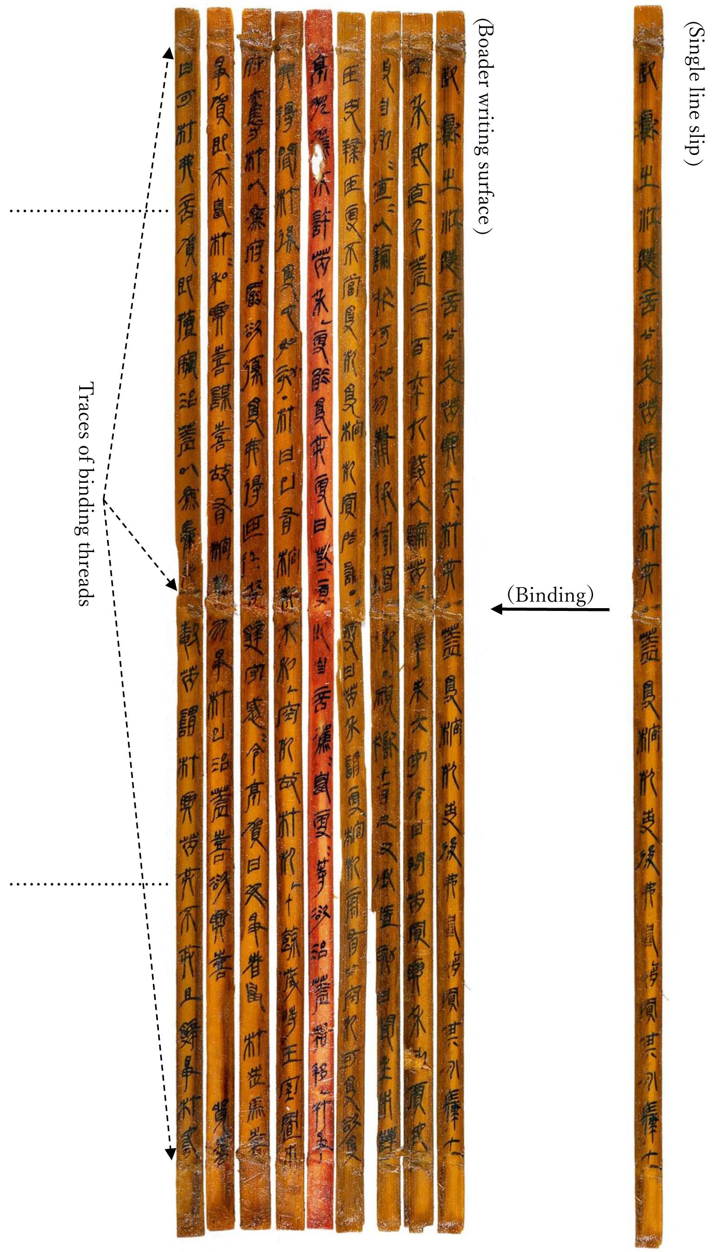
Figure 1: Physical appearance of excavated literature
Figure 2 arranges documents of diverse shapes from the Liye-site, which also date to the time of the First Emperor.
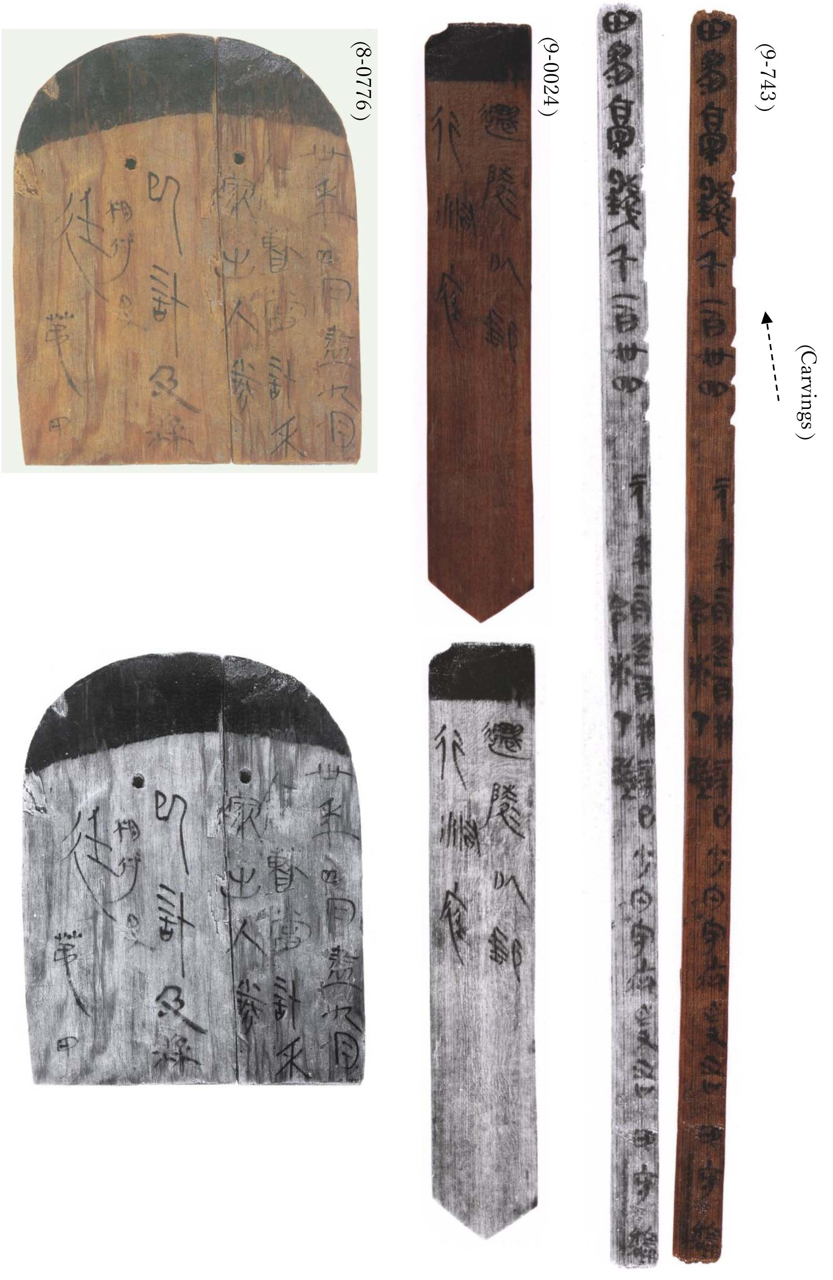
Figure 2: Physical appearance of excavated documents (Liye-site)

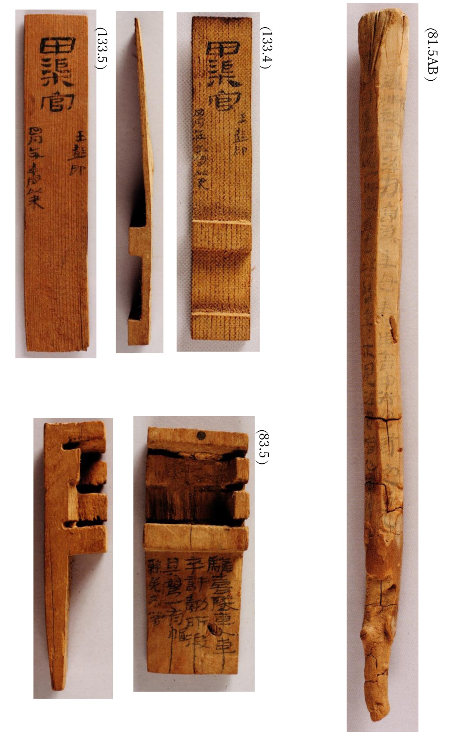
Figure 3 shows wooden tablets with three-dimensional processing features from the Juyan district, which date to a period from the middle of the Western Han to the beginning of the Later Han.
Figure 3: Physical appearance of excavated documents (Juyan-site)
For practical reasons, this paper concentrates on paleographic issues. The research on excavated literature and excavated documents is split into two specialized fields, Early Chinese Philology (Gǔ wénxiàn xué古文獻學·) and Chinese Paleo-diplomatics (Gǔ wénshū xué古文書學). The two distinct fields overlap in Chinese Paleography (Gǔwénzì xué古文字學), which is their common tool in accessing the principal literal features of their separate research objects. The implementation of the TEI-guidelines on Chinese paleography is the first essential step toward its further specialized application to the two different academic fields. Therefore, this preliminary paper restricts its scope to the common interest of the two fields. The aforementioned compilation of judicial cases dating back to the time of the First Emperor will be frequently used for demonstration purposes. For convenience, the paper will refer to it as “the compilation”.

- The encoding of traditional markup language
  - The traditional markup language
In praxis, Chinese paleography is the art of transcribing and collating early Chinese manuscripts. At the outset, paleography was primarily focused on the recognition and comparative analyses in space and time of what were known as pre-Qin characters (Xiānqín wénzì先秦文字), i.e. characters prior to the unification of Chinese characters under the First Emperor of the Qin. However, the abundance of excavated written materials led to an increased interest among paleographers in the development of script during the Western and Eastern Han periods in recent decades. Now, the range of paleographic research reaches down to the late second and early third century CE, when Kǎishū楷書, or "standard script", emerged. This new lower limit of paleographic research approximately overlaps with the end of industrial production and consumption of wooden tablets and bamboo slips as writing materials and their replacement by paper, making Chinese paleography a convenient and indispensable tool for the deciphering of wood and bamboo documents or manuscripts.
To keep track of how modern transcribers interpret the original text, Chinese paleography has developed a distinctive markup language for storing this information. It is without doubt the most essential requirement for any encoding of pertinent texts to retain the information found in paleographic markup. Therefore, its basic content should be briefly introduced here.
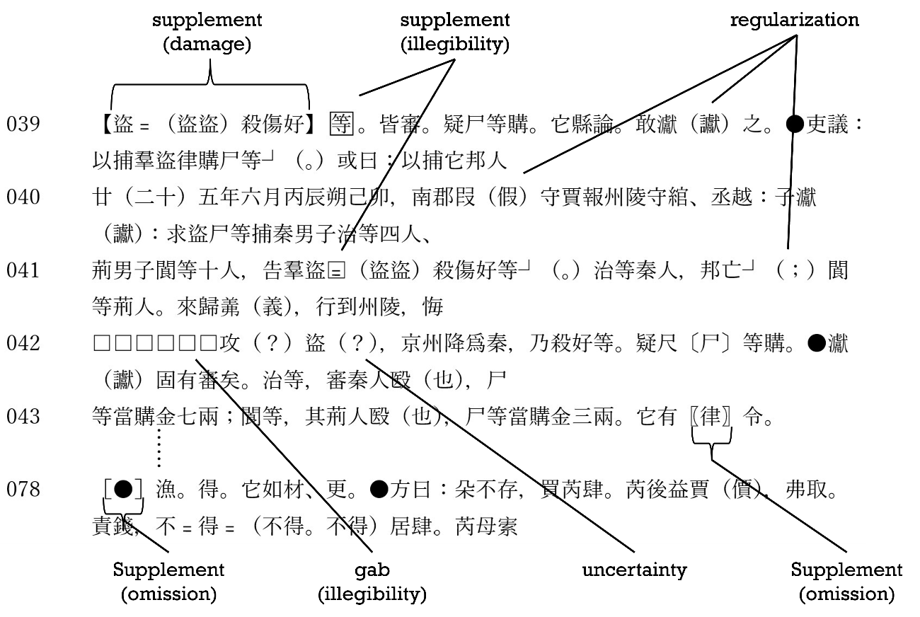
Figure 4 shows an excerpt of the transcription of the compilation. The Arabic numbers refer to the serial number of slips in the modern text arrangement. The text is divided into indented paragraphs according to its appearance on the slips, one separate paragraph represents the string of characters found on one slip. The boxes and various brackets dispersed throughout the text are examples of the said paleographic marking language.
Figure 4 Example of transcription with “enriched” traditional markups

Like the brackets and the boxes, punctuation marks also comprise an information layer that reflects the transcribers’ comprehension of the text. In many editions of excavated manuscripts or documents, a highly enriched markup transcription is often accompanied by a more restrained transcription, which is considered closer to the “original” literal appearance of the text. This sort of “literal” or “restrained” transcription of the same text example as in figure 4 looks like figure 5.
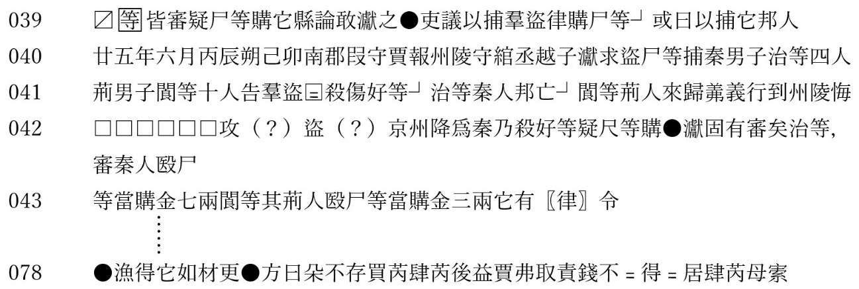
In this restrained version, the supplements for omitted or illegible characters remain in place because literal parts of the imagined original text would be absent otherwise. The parenthesized question marks expressing uncertainty are usually maintained too. “●” and “┘” are standardized modern representations of two typical sorts of original punctuation marks. “〼” marks the loss of a slip fragment at the beginning or end of the remaining text fragment. In the enriched version, the lost text was supplemented in black lenticular brackets (“【】”).
Figure 5 Example of transcription with “restrained” markup

  - Semantic correlations between traditional markup and TEI-elements
As the markup language reflects the transcribers’ comprehension of a particular text, the usage can differ slightly across different transcriptions. For a responsible transcription, it is essential to give an overview of the marking elements. Figure 6 shows the legend used in my edition of the compilation.
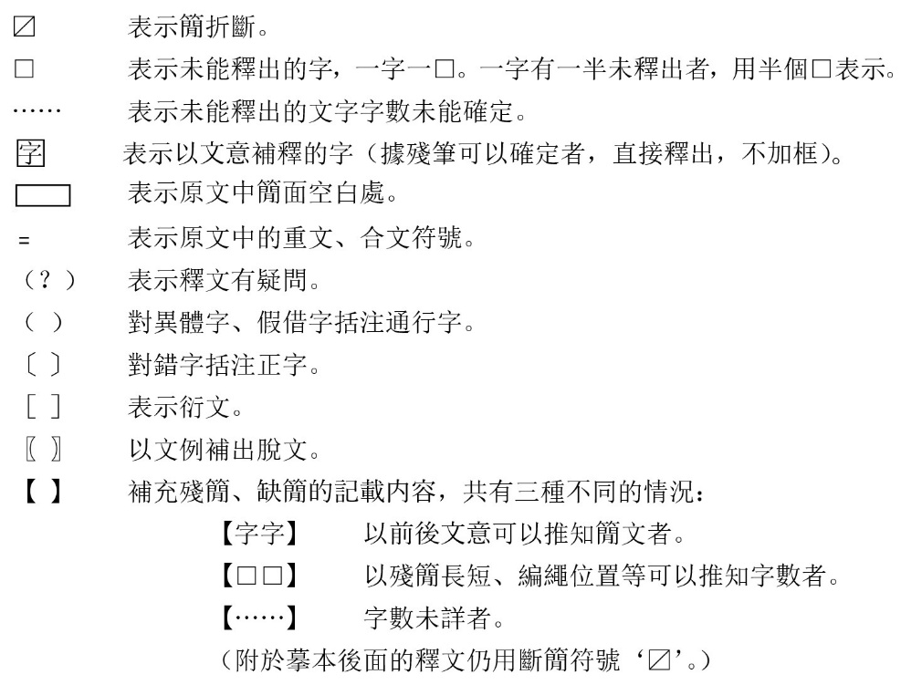
Figure 6 Exemplary legend of traditional markup language
It is astonishing how neatly the semantic meaning of these elements of the traditional markup language overlaps with well-known elements and attributes in the TEI-guidelines. Therefore, a comparison like the table 1 may be more eloquent and helpful for the non-Sinophile audience than individual explanations by the author.
Table 1 TEI-Element rendering of traditional markups
Traditional  Markup | Text Example | TEI-Element Rendering
□ | □ | <gap reason="illegibility" quantity="1" unit="char"/>
…… | …… | <gap reason="illegibility" extent="unknown quantity of characters"/>
<supplied reason="illegibility">等</supplied>
（also : <g ref ="#dddd" type="context">, s.3.2.）
﹦ | 粟﹦（粟米）  癸﹦等﹦（癸等。癸等） | <choice><abbr>粟<am> ﹦</am></abbr>  <expan>粟<ex>米</ex> </expan>  </choice>  <choice>  <abbr>癸<am> ﹦</am>等<am> ﹦</am></abbr>  <expan>癸等。<ex>癸等</ex></expan>  </choice>
（？） | 癸（？） | 癸<certainty locus="value" degree="0.6"/>  (also : <g ref ="#dddd" cert="low", s.3.2.>
（ ） | 𤅊（讞） | <choice><orig>𤅊</orig><reg>讞</reg></choice>
〔 〕 | 尺〔尸〕 | <choice><sic>尺</sic><corr>尸</corr></choice>
［ ］ | ［●］ | <surplus reason="redundant">●</surplus>
〖 〗 | 〖律〗 | <supplied reason= "omission" >律</supplied>
【 】 | 【盜盜殺傷好】 | <supplied reason= "damage" >盜盜殺傷好</supplied>

In recent transcriptions, a few of these markup symbols tend to be confused. A common source of confusion involves the information linked to the tortoise shell brackets ("〔〕"). They should be strictly distinguished from square brackets (“［］”), but they get intermingled often so that tortoise shell brackets or angle brackets are used to express corrections to alleged misspellings and to point to redundant characters. Another common conflation is the application of black lenticular brackets ( “【】”) to different sorts of uncertainty, ranging from doubts in the transcription to context-based supplementary transcription of characters lost because of surface damage, etc. Of course, these confusions lead to huge losses of transcription information and should, for the purpose of best practice, be avoided.

  - Basic Thoughts on automated recognition and encoding
As the discovery of Early Chinese written materials started right from the beginning of the 20th century, an abundance of transcriptions of wooden tablets and bamboo slips has been accumulated since then and is waiting to be properly encoded. Manual encoding would indeed prove to be a grueling task that is likely to be marred by errors. An automated way of recognizing and encoding the traditional markup language is therefore strongly desirable.
In my view, old-fashioned regular expressions are the most reliable tool for the recognition part of the task, and almost any programming language would easily do the job of rendering the recognized markups into TEI-elements. In theory, a reliable text file version of the original text, a list of regular expressions capable of matching the various markup symbols, and some basic programming skills are all that we need to accomplish this task.
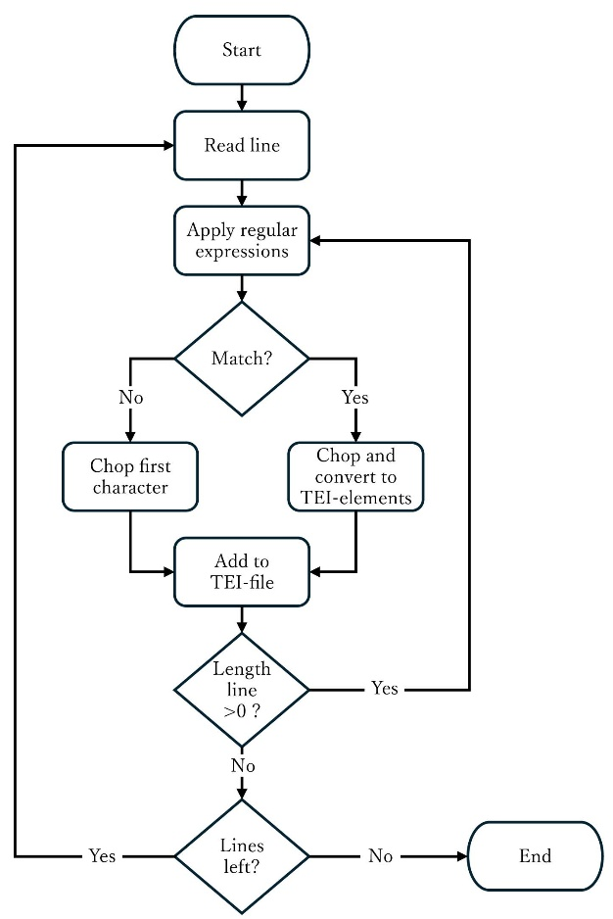
The basic flow of a script for automated recognition and encoding could be imagined as follows: The script processes each line of the original transcription sequentially, with each line correlating to the sequence of characters carried by a single slip in the original text. For each line, the script hovers over the text character by character and checks for markups connected with the specific character by applying a list of regular expressions. If markups are detected, the script chops off both the character and its markups, then assigns encoding to a corresponding subroutine which outputs the encoded form of the character. Otherwise, only the first character is chopped off without any further modification. After each chopping process, the pertinent character is added to a <p> element that holds the serial number of the slip carrying the character as an @xml:id attribute. The flow chart appears as figure 7.
Figure 7 Flow chart of automated encoding
Table 2 shows the regular expressions that could match the markups listed in table 1. The only markup that cannot be accurately represented in text format is the “”, an illegible character supplied by the transcriber based on context information, indicated by a box around the supplied character. In the experiments with automated recognition, this markup was substituted with a postposed two-byte ampersand (“＆”).

Table 2 Regular expressions recognizing traditional markups
Traditional  Markup | Text Example | Regular Expressions
□ | □ | r'^□'
…… | …… | r'^……'
 |  | r'^(.)＆' (Internal variable \1 catches supplied character)
﹦ | 粟﹦（粟米）  癸﹦等﹦（癸等。癸等） | r'^((?:.﹦)+)（[^）]+）'  (Internal variable \1 catches the abbreviation, variable \2 the expansion)
（？） | 癸（？） | r'^(.)（？）' (Internal variable \1 catches the character in doubt)
（ ） | 𤅊（讞） | r'^(.)（(.)）' (Internal variable \1 catches the original character, variable \2 the regularized character)
〔 〕 | 尺〔尸〕 | r'^(.)〔(.) 〕' (Internal variable \1 catches the original character, variable \2 the corrected character)
［ ］ | ［●］ | r'^［(.)］' (Internal variable \1 catches the redundant character)
〖 〗 | 〖律〗 | r'^〖(.)〗' (Internal variable \1 catches the redundant character)
【 】 | 【盜盜殺傷好】 | r'^【([^】]+)】' (Internal variable \1 catches the supplied characters)

  - Practical obstacles to automatization
In practice, some peculiarities made finding the proper regular expressions and their subsequent processing more complicated than anticipated initially. First, the abbreviation markers found in the original texts (“﹦”) are used as a shorthand for the replication or duplication of both characters and character components. The former is named chóngwén重文(character duplication), and the latter héwén合文( =character composition, compound character) in modern Chinese terminology.
Table 1 in the previous section listed the compound character “粟﹦”, which is a composition of the abbreviation marker “﹦” with the character “sù粟(millet/ grain)”. The character “sù粟” entails the character “mǐ米(rice)” as a building component, the abbreviation marker indicating the duplication of this character component. Since the component is replicated as an independent character, the expansion stands for the compound word “sùmǐ粟米(threshed grain or rice).
The challenging aspect of compound characters lies in the random positioning of duplicated character components. While the duplicated component “mǐ米” in “sùmǐ粟﹦” is postposed, the component “dà大(large)” in the compound character “夫﹦” is supposed to be preposed, resulting in the compound word “dàfū大夫(denomination of an official or social rank)”. The expansion of the abbreviation “sùmǐ粟﹦” leads to an “AB” structure, whereas the abbreviation “dàfū夫﹦” turns into “BA”, with “A” representing the original character originally and “B” for the editorial expansion. Table 3 illustrates the same difference by translating the abbreviation and its expansion into TEI-elements.
Table 3 Comparison of different expansions of compound characters
sùmǐ粟﹦ | <choice><abbr>粟<am> ﹦</am></abbr>  <expan>粟<ex>米</ex> </expan>  </choice>
dàfū夫﹦ | <choice><abbr>大<am> ﹦</am></abbr>  <expan><ex>大</ex>夫</expan>  </choice>
The character duplication (chóngwén重文) listed in Table 1 is “guǐ癸﹦děng等﹦”. “Guǐ” is the personal name of a culprit, “děng” meaning “others/ et al.”. The length of the duplication expression can range from duplication of a single character (“A﹦”) to the duplication of three to four characters (“A﹦B﹦C﹦D﹦”), but the expansion of such duplication expressions is quite regular in general, “A﹦”, “A﹦B﹦”, “A﹦B﹦C﹦”, “A﹦B﹦C﹦D﹦” resulting in “AA”, “ABAB”, “ABCABC”, “ABCDABCD” respectively. However, the expansion text is prone to entail multiple modern punctuation marks, whose distribution appears to be more or less arbitrary.
The abbreviation example “guǐ癸﹦děng等﹦” in Table 1 has been taken from slip 6 of the compilation. The expansion reads “guǐděng癸等。guǐděng癸等”. The first “guǐděng” was understood as the object to the predicate of the preceding sentence and the second “guǐděng” as signaling the subject of the following sentence. Thus, both were separated by a period (“。”). Not only the sort of punctuation mark separating the original phrase from the editorial expansion can vary depending on the context, or the transcriber’s understanding of the context, there can also appear punctuation marks within both the original string and the editorial expansion. For example, slip 134 of the compilation holds the expression “sì肆﹦shì室﹦”, “sì” and “shì” meaning “store, shop” and “house” respectively. As “sìshì” itself is a list of two nouns that need to be separated by a comma, the entire expression turns into something like “sì肆﹦shì室﹦（sì肆、shì室。sì肆、shì室）”, entailing three modern punctuation marks in total.
Another aspect adding complexity to automated traditional markup processing involves the accumulation of various markups associated with a single character in the original text. The most common combination of marks is the inclusion of the uncertainty marker “（？）” in other markups. In such cases, the parentheses around the two-byte question mark (“？”) are omitted. For instance, the character “yǐ已(=already)” is written in the shape of the modern character “sì巳” on slip 121 of the said compilation. Without any uncertainty, this would result in the transcription “巳（已）”, an equivalent to the TEI element “<choice><orig>巳</orig><reg>已</reg></choice>”. Since there remain some doubts about the deciphering of the original shape “巳”, a question mark was added in front of the regularized writing form “已”, which turned the entire transcription of this single character into “巳（？已）”. Likewise, the transcription “詣﹦（？詣，詣）” in slip 158 expresses uncertainty about the transcription of the abbreviation marker “﹦”.
The position of the uncertainty marker can also change to a postposition to the regularized writing form, as in “臞（虞？）” on slip 166. Before this appearance, it has been unknown that the character “yú虞(= to scheme, transferred meaning deriving from to plan)” could be written in the shape of “臞”, which ordinarily is read “qú (=emaciated)”. In the first edition of the compilation from 2013, the author did not dare to regularize “qú臞” into “yú虞” and rendered the entire character as a gap (“□”), based on the fact that a small part of the shape “臞” was incomplete. After extensive deliberation, the author realized that he could not continue dodging the recognizable shape “臞” of this character and, based on the context, rendered it tentatively as the character “yú虞”.
Within the transcription of the compilation, instances of inclusion of the uncertainty marker are limited to regularizations and renderings of abbreviation marks. However, uncertainty markers can appear in almost all other markup types, and pertinent instances are found in other excavated literature and in excavated documents. An example from the administrative documents discovered in an abundant well at the Liye-site, Hunan province, might suffice. On tablet 5-31, the character “suǒ所 (=place)” appears to have been mistakenly written as a “jīn斤 (= a unit of weight)”. Because the fragmentary context doesn’t provide sufficient proof, uncertainty remains, which could be rendered as “斤〔所？〕”, equivalent to “<choice><sic>斤</sic><corr>所<certainty locus="value" degree="0.6"/></corr></choice>”.
Moreover, the aggregate usage of various markups extends beyond just incorporating uncertainty indicators. The regularization marker is often joined with other markers through hyphenation. For instance, the shape “𣄵” on slip 143, which usually is read “liàng (=expression of despise against negative events), is the mistaken form of the character “jiù就”, which in this case should be rendered into the regularized form “jiù僦”, as it expresses the meaning of “to hire”. The corresponding transcription is “𣄵〔就-僦〕”, which is equivalent to the TEI-element “<choice><orig><choice><sic>𣄵</sic><corr>就</corr></choice></orig><reg>僦</reg></choice>”.
Another example is the transcription “言（音-意）” on slip 145. In this instance, “yì意” functions as a verb carrying the meaning “to intend”. In paleographic sources, this verb is often written in the shape of “音”, which is ordinarily read “yīn (=sound)”. To render the shape “音” into the character “yì意”, the typical transcription would be “音（意）”. In this special case, however, we witness the rare phenomenon that the shape “音” is replaced by the etymologically akin shape “言”, which as a modern character would be read “yán (=to speak)”. Given the close association between “音” and “言” in early Chinese writtings, the usage of the shape “言” cannot be regarded as an error. Rendering of “言” into “音” ought to be viewed instead as a kind of regularization within the framework of early character usage. Put differently, the stated transcription constitutes a dual regularization. The first regularization renders the rare ancient form of “言” into the commonly seen ancient form of “音”; the second regularization turns the ancient form of “音” into the modern character “yì意”. The corresponding TEI-element would be “<choice><orig><choice><sic>言</sic><reg>音</reg></choice></orig><reg>意</reg></choice>”.
Regularization is also coupled with the expansion of abbreviations. For example, slip 185 carries the string “气﹦鞫﹦”. Merely expending the abbreviation would result in the transcription “气﹦鞫﹦（气鞫，气鞫）”. However, “气”, usually read “qì (=gas, air) is the early shape for the modern character “qǐ乞 (to beg)”, regularization of which should be transcribed as “气（乞）”. The combination of the two markups results in “气﹦鞫﹦（气-乞鞫，气-乞鞫）”, an equivalent to the TEI-element “<choice><abbr>气<am>﹦</am>鞫<am>﹦</am></abbr><expan><choice><orig>气</orig><reg>乞</reg></choice>鞫， <choice><ex>气</ex><reg>乞</reg></choice><ex>鞫</ex></expan></choice>”.
Generally speaking, the aggregate usage of different markups merely complicate the regular expressions required to accurately identify the traditional markup language used in transcriptions. By contrast, the inclusion of uncertainty markers within expansions of abbreviations can result in ambiguities that necessitate manual intervention. Given that the parentheses are omitted in the such cases of inclusion, the shape of the uncertainty marker blends indistinguishable with the modern question mark, both being written in the two-byte form “？”. Thus, the question mark in the expression “別﹦直﹦（別直？別直）” could easily be misinterpreted as an uncertainty marker.
Similar ambiguities arise in cases where original punctuation marks are standardized into modern question marks. On slip 82 a question is divided from the following sentence by an original punctuation mark in the shape of “┘”. Separation marks of this kind were employed to separate single words, clauses, or even entire sentences. Accordingly, the rendering into modern Chinese punctuation marks as part of a regularization can vary from two different forms of commas, “，(dòu hào逗號)” and “、(dùn hào頓號)”, to periods (“。jù hào句號”)，and to question marks or exclamation marks (“？wèn hào文號”, “！gǎntàn hào感嘆號”), etc. Sometimes, the said separation mark is used in situations where modern Chinese punctuation is not necessary. In such cases, it would be merely transcribed as “┘”. Hence, the transcription “┘（？）” on slip 82, which actually is the result of a regularization, cannot be discerned from an uncertainty marker “（？）” put behind the original punctuation mark “┘”.
Furthermore, the cumulative use of markups within the supplement marker “【】” requires some adjustment within the flow chart. The slips 17, 39, and 223 contain the following supplements for text fragments lost by damage to the slips:
17 【萬六百卌（四十）錢。……】
39 【盜﹦（盜盜）殺傷好】
223 【癸﹦（癸，癸）攺（改）】
In all the three cases, the supplement is indicated by the supplement marker “【】”. Other markups appear in a seemingly arbitrary distribution among the supplied characters. Regularizations ( “卌（四十）” and “攺（改）”) are found for the fourth and the third characters of slip 17 and 223 respectively; abbreviations (“盜﹦（盜盜）” and “癸﹦（癸，癸）”) at the beginning of the supplement to slip 39 and 223, and a gap of unknown quantity (“……”) at the end of the supplement to slip 17.
At least two approaches exist for dealing with these aggregated markups. One method is to recursively input the supplied text fragment as an independent text line. After catching the supplements “萬六百卌（四十）錢。……”, “盜﹦（盜盜）殺傷好”, and “癸﹦（癸，癸）攺（改）” with the help of the regular expression r'^【([^】]+)】', the script hovers over the text fragment character by character, checks for markups, and chops off characters and markup expressions, just as shown in figure 7 for ordinary text lines. The sole distinction is that the encoded output is not stored directly in a final <p> element but is instead returned to the sub-routine that handles the encoding of supplements. Only after the encoding of the entire output as a supplement is it finally added to the <p> element.
Depending on the script’s design, recursive input and the handling of its output might entail certain challenges. If so, an alternative way to handle it exists. The regular expression r'^【([^】]+)】' is divided into the two separate expressions r'^【' and r'^】'. Every time the first expression matches, a flag is activated, instructing all following sub-routines to direct their output into a temporary variable. Each time the second expression matches, the flag is reset, and the temporary variable’s contents are passed to a subroutine responsible for the concluding encoding and storage of the supplement.

  - Preliminary experiments with automatization
Following several attempts to surmount the practical challenges noted previously, an initial script was crafted to convert traditional transcriptions of Chinese excavated literature into TEI-conform XML files. The entire script and related files can be freely downloaded from a Japanese website maintained by the author and collaborating Japanese colleagues.
The regular expressions that were finally used to match and recognize traditional markups are listed in table 4.
Table 4 Regular expressions used in the initial conversion script
Traditional  Marker | Text Example | Regular Expressions
﹦ | 粟﹦（粟米）  癸﹦等﹦（癸等。癸等） | r'^((?:(?:｛[^｝]+｝|[^（）＆﹦])(?:（？）)?＆?﹦＆?)+)（([^）]+)）'  (Internal variable \1 catches the abbreviation, variable \2 the expansion)
●/┘ | ●/┘ | r'^([●┘])(＆?)（?(？?)([。，、？！：；]?)）?'  (Internal variable \1 catches the original punctuation mark “●” or “┘”, variable \2 an eventual supplement marker “＆”, and variable \3 an eventual regularization marker)
（？） | 癸（？） | r'^(｛[^｝]+｝|.)(＆?)（？）'  (Internal variable \1 catches the character in doubt, variable \2 an eventual supplement marker “＆”)
［ ］ | ［●］ | r'^［([^］]+)］'  (Internal variable \1 catches the redundant character)
（ ） | 𤅊（讞） | r'^(｛[^｝]+｝|.)(＆?)（([^）]+)）'  (Internal variable \1 catches the original character, variable \2 the regularized character)
〔 〕 | 尺〔尸〕 | r'^(｛[^｝]+｝|.)(＆?)〔([^）]+)〕'  (Internal variable \1 catches the original character, variable \2 the corrected character)
□ | □ | r'^□'
…… | …… | r'^……'
〖 〗 | 〖律〗 | r'^〖' and r'^〗'
【 】 | 【盜盜殺傷好】 | r'^【' and r'^】'
r'^(｛[^｝]+｝|.)＆'
(Internal variable \1 catches supplied character)
- | - | r'^([。，、；：？！])'  (Internal variable \1 catches modern punctuation marks that are not based on the regularization of the original punctuation marks “●” and “┘”)
- | - | r'^(｛[^｝]+｝|.)'  (Internal variable \1 any Unicode or non-Unicode character that is left over after all other regular expressions failed to match)

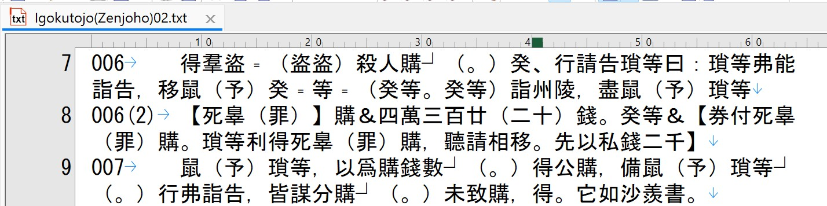
The script was applied to the text of a revised edition from 2021 of the compilation. The text was stored in a text file named “Igokutojo(Zenjoho)02.txt”, whose appearance basically looks like figure 8.
Figure 8 Input file automated encoding (revised edition from 2021 of the compilation)
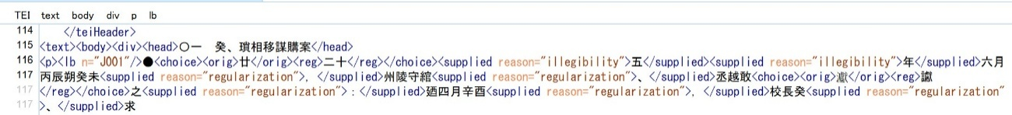
The script's output is an XML file in TEI-conformant format, with TEI-elements embedded directly within the main text body. Figure 9 displays the initial portion of the main text.
Figure 9 TEI-conform xml output file of the compilation
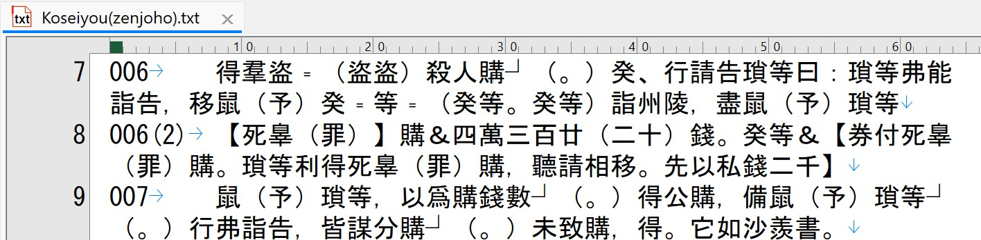
To ensure the accuracy of the encoding, XSL-Transformations were employed to revert the output file into two distinct text documents. One contains the full transcription including all modern regularizations, corrections, and supplements; the other contains a simplified transcription without regularizations etc. that comes closer to the original appearance of the text. Figure 10 displays the original "enriched" transcription that aligns with the version I incorporated into the infrared slip images in the first edition of the compilation.
Figure 10 XSL-Transformation output in form of an “enriched” transcription
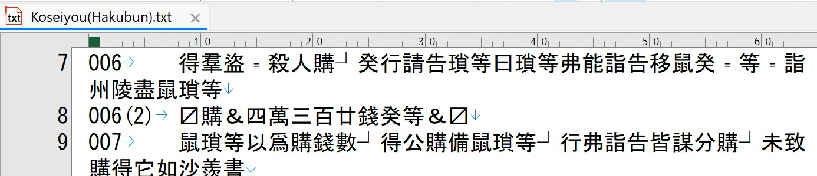
Figure 11 illustrates the latter "restrained" transcription. It aligns with the version that was incorporated into the color images of the slips from the initial edition published in 2013.
Figure 11 XSL-Transformation output in form of an “restrained” transcription
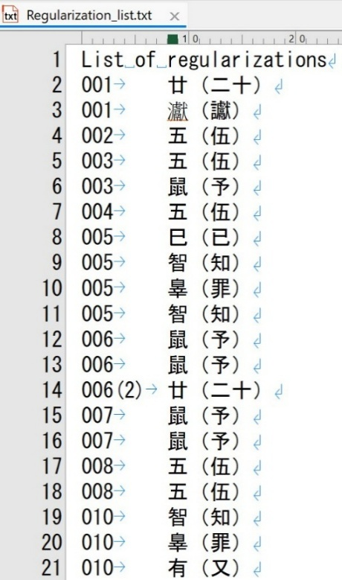
Figure 12 Regularization list output via XSL-Transformation
As the output of text information can be easily controlled by XSL transformation, a wide range of applications open up. For example, limiting the output to regularizations results in a list of characters that conventionally have been categorized as phonetic loan characters (tōngjiǎ zì通假字), like figure 12.
The automated encoding was programmed using Python. Python is a highly object-oriented programming language, while XSLT is strongly influenced by functional oriented languages, which makes it work completely differently. The author must confess that he had a much harder time getting accustomed to using templates matching xml-elements than when starting to learn Python a few years earlier. The more the outcome of the XSL-transformation confesses. The consistent results across different programming languages prove the machine's readability and the reliability of the recognition systems.

- Automated text collation
  - Automatization enhancing syntax considerations 1
Traditional paleography has piled up huge amounts of research results since the first discovery of early Chinese wooden and bamboo texts at the dawn of the 20th century. Automated encoding as described in the previous chapter enables us to easily carry on these results into the digital age. There are many things that we can do with the encoded digital texts, such as further semantic and syntactical annotations, connecting different texts and text fragments based on these annotations, etc. Before getting indulged in such dreams, the author would like to automize another basic task of paleography or philology in general, i.e. text collation.
We possess various transcriptions of the same excavated text alongside different excavated witnesses of identical, similar, or related early texts. Collating these texts and text fragments is the first step toward in-depth comprehension of the text, but it can be painstaking, time-consuming, and sometimes even monotonous or dull. Automatizing this task appears to be a natural demand. This chapter will describe some syntax considerations that facilitated the development of an experimental version of automated text collation. The texts utilized for the experiment were two distinct transcriptions of the compilation, which has already extensively been employed in the previous chapter.
No question whether automated or manual processing, the degree of complexity easily affects the accuracy of the collation. The greater the number of different layers of information processed at once, the higher the probability of misinterpretations and errors. In this regard, the inline encoding introduced in the previous chapter causes unnecessary complexity by scattering mutual unrelated annotations over the entire text in a highly arbitrary manner. Let us take a closer examination of the first two lines of text displayed in figures 7, 9, and 10:
006 得羣盜﹦（盜盜）殺人購┘（。）癸、行請告瑣等曰：瑣等弗能詣告，移鼠（予）癸﹦等﹦（癸等。癸等）詣州陵，盡鼠（予）瑣等
006(2) 【死辠（罪）】四萬三百廿（二十）錢。癸【券付死辠（罪）購。瑣等利得死辠（罪）購，聽請相移。先以私錢二千】
On slip 6 and 6(2), we observe the following annotations:
6 character regularizations (3 of them within a supplement)
1 punctuation mark regularization
2 abbreviations and their expansions
2 supplements for damaged text fragments (both entailing character regularizations)
2 supplements for illegible characters
8 supplementary modern punctuation marks (3 of them within supplements)
Even in traditional analog collation, these annotations can easily cause confusion. It would be much easier if we initially separated the annotations from the main body of text.
Main body of text:
006 得羣盜﹦殺人購┘癸行請告瑣等曰瑣等弗能詣告移鼠癸﹦等﹦詣州陵盡鼠瑣等
006(2) 購四萬三百廿錢癸等
Character regularization:
Slip 6 position 23 鼠（予）
Slip 6 position 32 鼠（予）
Slip 6(2) position 6 廿（二十）
Slip 6(2) supplement 1 position 2 辠（罪）
Slip 6(2) supplement 2 position 4 辠（罪）
Slip 6(2) supplement 2 position 11 辠（罪）
Punctuation regularization:
Slip 6 between position 8 ┘（。）
Expansion of abbreviations:
Slip 6 position 3-4 盜﹦（盜盜）
Slip 6 position 24-27 癸﹦等﹦（癸等。癸等）
Supplements for damaged text fragments:
Slip 6(2) before position 1 【死辠】
Slip 6(2) after position 9 【券付死辠購瑣等利得死辠購聽請相移先以私錢二千】
Supplements for illegible characters:
Slip 6(2) position 1
Slip 6(2) position 1
Supplementary modern punctuation marks (omitted)

To achieve the same segregation and systematic organization in our encoding, we must transform the inline annotations into stand-off apparatuses categorized based on the annotation's content. The double-end-point-attached method allows us to do so. A comparison will illuminate the decrease in complexity. Figure 13 shows the inline version created by the script described in the previous chapter:
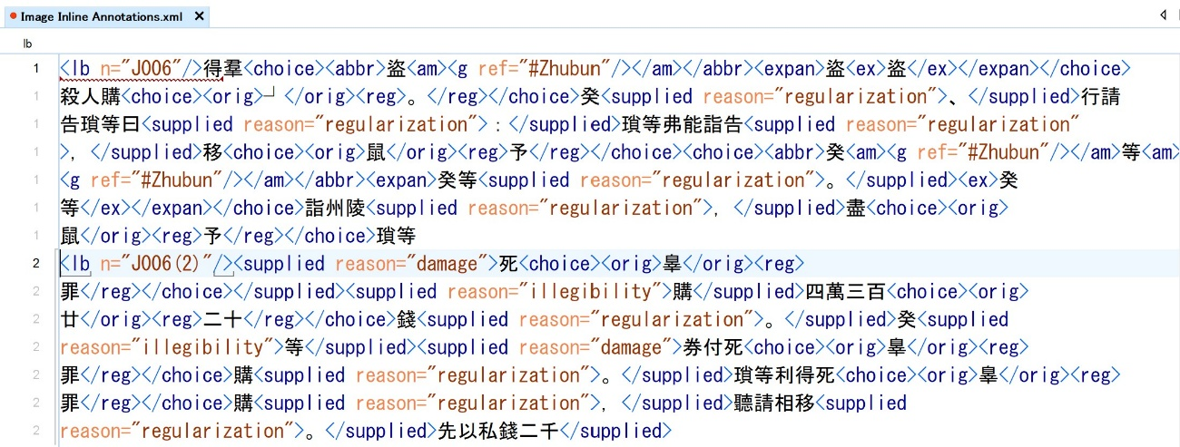
By contrast, the stand-off version looks like figure 14:
Figure 13 Example of inline encoding
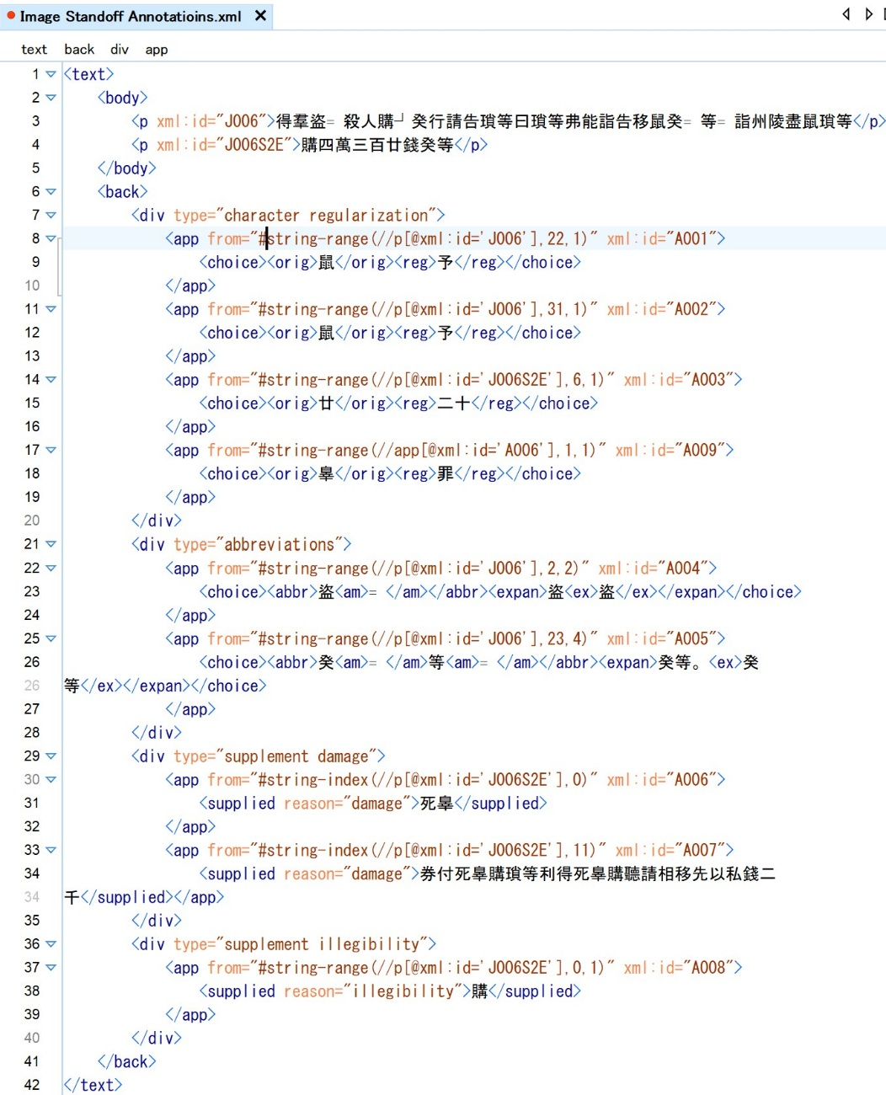
Figure 14 Example well-sorted stand-off encoding
It should be self-evident that the comparison of well-sorted stand-off encodings needs far less complex comparisons. Different layers of information are pre-configured; all comparisons can be limited to a range of basically homogeneous sequences, i.e. simple strings in the main body, Arabic numbers in the links of the apparatuses, and XML elements with completely identical structure in the apparatuses. Since even the comparison of xml-elements with identical structure amounts to nothing more than the comparison of text-nodes entailed, the subject of the entire comparison process gets reduced to linear sequences of either characters or numbers.
Furthermore, the separation and classification of annotations in the stand-off version are also advantageous for adding multiple layers of annotation to the text. As mentioned before, additional semantic and syntactic annotations are highly desirable. These annotations might well involve intricate levels of nesting and overlap. Given that overlaps among xml-elements are not permitted, the complexity of the annotation layers would be extremely constrained in the scenario of inline annotation. Using separated and categorized stand-off annotations avoids this kind of limitation, since overlapping of annotations merely results in overlaps in link ranges that are nothing more than abstract numbers and not in overlaps of XML elements.

  - Automatization enhancing syntax considerations 2
The text examples given in the previous section did not contain any non-Unicode characters. As a matter of fact, the proportion of non-Unicode characters in the compilation as well as other written material of the Qin and Han periods is notably smaller compared to those found in bronze inscriptions of earlier times or in bamboo texts excavated from tombs within the area of the Warring States Period state of the Chu. This is because even modern Chinese script still remains significantly influenced by the script unification conducted during the reign of the First Emperor of the Qin, and the script unification itself was highly influenced by the actual character usage within the realm of the Warring States Period state of the Qin. The genealogical proximity to the modern Chinese script helped to ensure that a huge part of the Qin script got included in the Unicode character set. By contrast, many earlier characters and characters from other regions were weeded out during the Qin’s character unification. Many were accurately recognized only recently; it will still take some time before they get reflected in Unicode.
However, a notable presence of non-Unicode characters persists in excavated literature and documents from the Qin and the following Han. Considerations are required with regard to their influence on the homogeneity of the character sequences that will be subject to comparison during automated collation.
In a legal case that is recorded on slips 171 to 188 of the compilation, there are 63 appearances of the character “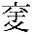”. It is used as the name of the victim of a sexual assault by her former husband in this case. The same name is frequently encountered in other excavated literature and documents as well as in personal seals. It appears to have been quite a common name, but, unfortunately, there are no occurrences of this character other than in personal names. Thus, it is impossible to exactly trace it down to any known later character.
In an article co-authored by the author and Chén Jiàn陳劍, we argued, based on suggestions by Shī Xièjié施謝捷, that the character could be broken down into the two components “交” and “于”, the corresponding Ideographic Description Sequence would be “⿴交于”. We also advocated that it could be a variant of the character “yū㝼 (=crooked thighs)”. Fāng Yǒng further developed the argument by suggesting that the component “交” actually is a variant of “黃“, which he interprets as the original shape of the character “wāng尪” (also “wāng𡯁”, the name of a disease inflicting spine deformations) based on a theory of Táng Lán唐蘭. According to Fáng’s comprehension, the character should be described as “⿴黃于” or “⿴𡯁于”, the latter neatly fitting into the argument that the character is just a variant of “yū㝼”.
What impact could these theories about this uncertain character have on automated collation? Let us review the initial instance of the character in the compilation. In my transcription the pertinent slip reads:
171 【……當陽隸臣得之气（乞）鞫曰：……】□，不與棄妻奸，未𧐂（蝕）。當陽論【得之爲】
According to the previous arguments, merely the reduced transcription of this text fragment, which would be stored in the main text body of the TEI-conform xml-file, could have the following variants:
1: □不強與棄妻⿴交于未𧐂當陽論耐
2: □不強與棄妻㝼未𧐂當陽論耐
3: □不強與棄妻⿴黃于未𧐂當陽論耐
4: □不強與棄妻⿴𡯁于未𧐂當陽論耐

The main obstacle that these variants pose is the fact that the number of characters varies although all four transcriptions suppose the same number of characters in the original text. In other words, the order of the characters loses the direct connection to the original text as understood by the transcriber. For instance, the glyph “𧐂”, which is regularized to the character “shí蝕” and, accordingly needs a link to an annotation, is the eleventh character in variation 1 and 3-4, but the ninth in variation 2. Corresponding links would easily point to different, unintended characters.
At the same time, comparison modules such as diff-lib are unable to distinguish between a character and a component of an Ideographic Description Sequence. This can easily result in misinterpretations if components of Ideographic Description Sequences appear as individual characters shortly before and after. For example, the results of automated comparison could be different if the character “wèi未” would have been understood as a “yú于” by the transcriber in variation 2, i.e. the character “yú于” would be considered an exact match to the IDS component “于”.
The TEI-guidelines provide the element <g>(gaiji) for the description of non-Unicode characters. If we substitute this element for Ideographic Description Sequences, we could prevent confusion between sequence components and independent characters. The unintended side effect would be that the reduced transcription would entail text nodes and element nodes in an arbitrary order. This again would be a challenge to the automated interpretation of the output of comparison modules like diff-lib.
To bypass this hurdle, I changed the semantic meaning of the element <g> to “g” meaning “glyph”. In my view, the paleographic interpretation of characters diverges significantly far from that of the Unicode consortium. Turning all Unicode and non-Unicode characters into homogeneous <g> elements opens up space for detailed character description in the <charDecl> element, while simultaneously maintaining the homogeneity of the comparison subjects. If all characters of a text are converted into <g> elements, text comparison essentially reduces to the comparison of the IDs assigned to the <g> elements. In general, these IDs consist of simple ASCII strings.
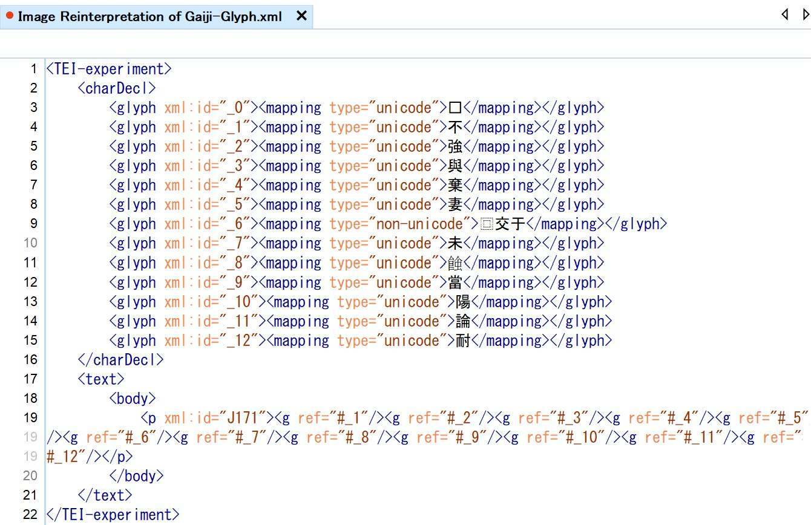
Applying this idea to the first variant of the text fragment on slip 171 would yield the <charDecl> and text body as depicted in figure 15:
Figure 15 Example of <g> elements representing glyphs
The encoding of the second variant would require the declaration of a new glyph, for instance “<glyph xml:id="_13"><mapping type="unicode">㝼</mapping></glyph>”. The output of an automated comparison would be that the difference between variation 1 and variation 2 is the replacement of the ID “_6” by “_13” at position 6.
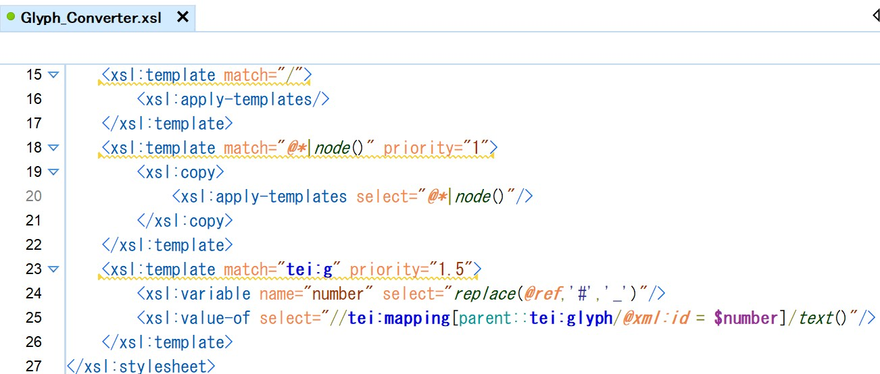
At first glance, the conversion of all characters into glyph-elements (<g>) appears to be counterproductive. For the human eye, the main text body is already incomprehensible. As figure 16 demonstrates, only about ten lines of an XSLT script are needed to convert the file into a readable format for humans. I am confident that the same transformation can be effortlessly through in a viewer used by experienced TEI users via Java script. Thus, human readability hardly qualifies as a major hurdle.
Figure 16 Example of script converting <g> elements into human readable glyphs
The use of <g> elements also allows for the incorporation of the two traditional markups typically used in "restrained" transcriptions, i.e. boxes for supplement transcriptions of illegible characters based on context and question marks in parentheses for uncertain transcriptions. A @cert attribute could switch between the values “high” and “low” to describe the certainty or uncertainty of transcriptions; a @type attribute could carry the values “original” and “context” to distinguish transcriptions directly based on the original glyph from those that were based on context information. Using the glyph IDs of the previous example, “” would result in ‘<g cert="high" ref="#_2" type="context">’; “強（？）“ in ‘<g cert="low" ref="#_2" type="original">’, and “（？）” in ‘<g cert="low" ref="#_2" type="context">’.

  - A prototype of automated text collation
The author carried out the ideas outlined in the preceding two sections using a Python script called "compare.py". This script takes multiple text files as witnesses to one original text. The script hovers over an ordered list of file names, reads the corresponding files in the listed order, and treats the first as the main witness against whom all other witnesses are collated. The main witness is assigned the ID “01”, while the others receive IDs “02”, “03” and so forth. After encoding all witnesses as outlined in section 3.1. and 3.2., the witnesses with the ID “02” and above are then compared to the main witness. Comparison is conducted information layer by information layer; each information layer comparison is processed witness by witness.
As a preparatory step, the witness ID of the main witness is stored in the @source attribute of the corresponding element for each information layer. A sequence of strings or numbers representing the stored information in the main witness is also generated. Thereafter, corresponding sequences are generated for all other witnesses and examined to see if they are identical to or divergent from the main witness. This comparison is conducted by one witness after the other. If identical, the witness ID is added to the @source attribute of the corresponding element; if divergent, an apparatus containing the diverging reading is created and stored in the corresponding <div> element in the <back>.
In summary, the entire collation process is comprised of the encoding of all witnesses, the preparatory processing of the main witness for each information layer, and the comparison of all other witnesses with the main witness, also for each information layer separately. Figure 17 displays the flow chart:
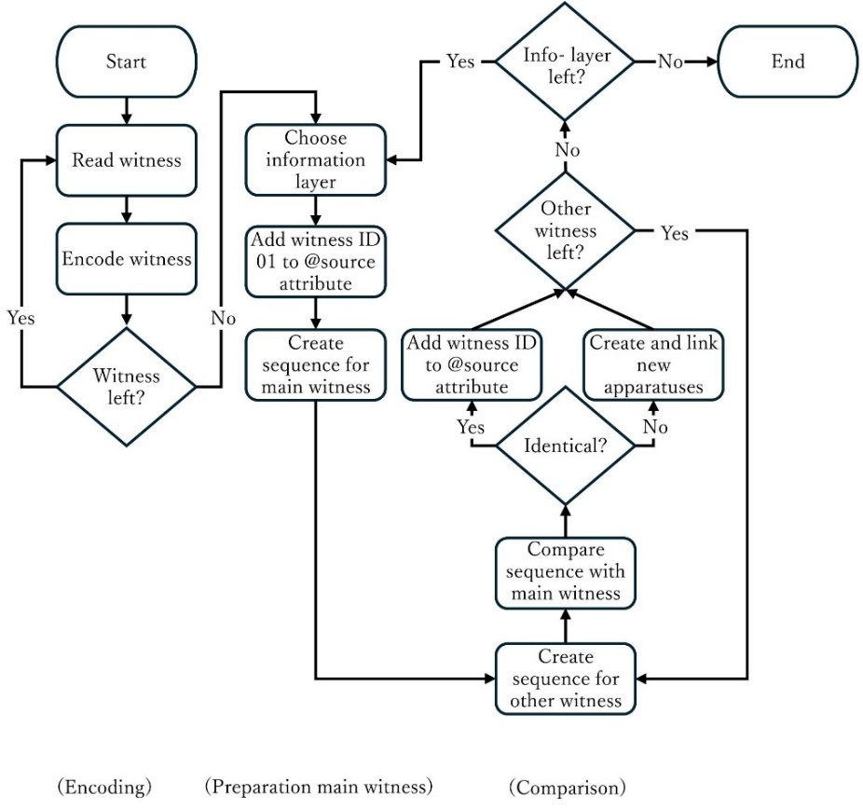
In addition to the annotation layers mentioned in 3.1., two further <div> elements are created, each with a @type attribute referring to divergences in the slip arrangement and variations in the main text. Currently, the automated comparison of the experimental script focuses exclusively on these two annotation layers; the remaining layers will be incorporated in future updates of compare.py.
Figure 17 Flow chart of automated text collation
The limitation on these two layers of information in the experiment should not undermine its reliability or effectiveness. As all information is orderly stored in separate element layers within the main text body or in separate annotation layers in the back matter, collation can also be conducted in an orderly way layer by layer. Increasing or decreasing the number of layers handled does not substantially change the processing complexity.
Let us inspect what the collation script is actually doing with the different witnesses.
Considering that the physical appearance of all witnesses in this experiment is determined by modern transcribers rearranging the bamboo slips, the initial task is to compare the different slip arrangements. Slips are identified by ID numbers. The script converts these numbers into @xml:id attributes and attaches them to the <p> element storing the text fragment found on the specific slip surfaces. The collation of slip arrangements gathers all @xml:id attributes for each text, converts them into string sequences, and then compares these sequences.
Sequence comparison typically yields four different results: 1) equal, 2) delete, 3) replace, 4) insert. For the collation of slip arrangements that means the following: 1) slip IDs found in the main witness are identical to slip IDs in another witness; 2) slip IDs found in the main witness are deleted in another witness; 3) slip IDs found in the main witness are replaced by another slip ID in another witness; 4) slip ID not found in the main witness is inserted by another witness.
We need to keep in mind that the results of comparison modules merely refer to specific positions within the main sequence. This can cause quite counter-intuitive results in the current experiment. For instance, if the comparison module states that a slip ID found in the main witness has been deleted in the other witness as in 2), that doesn’t mean that the said ID cannot be found at another position in that sequence. For our collation purposes, it would be necessary to conduct further inquiry into whether the deleted slip ID is found at a different position or is completely absent in the other witness. We could label the former result as 2a) and the latter as 2b). The same applies to result 4). For 3), there can be found even four sub-categories: 3a) The two slip IDs (or the two sub-sequences of slip IDs) are found in both witnesses, but at different positions; 3b) the two slip IDs are exclusively found in only one of the witnesses each; 3c) the slip IDs found in the main witness are exclusive, while the other slip IDs can be found in both witnesses at different positions; 3d) the slip IDs found in the other witness are exclusive, while the slip IDs of the main witness are also found in the other witness at another position.
This rather unexpected outcome of the comparison modules stems from the fact that they compare “sequences”, whereas the slip arrangement is a list of ordered elements (i.e. slip IDs) without repetition. In mathematics, a “sequence” constitutes an ordered collection of elements that allows repetition of values. By contrast, slip IDs constitute a “set”, i.e. a collection of different things. In plain words, each slip ID is unique. Reconstructing the order of slips, or the text, can be understood as selecting a subset of slip IDs from the larger set of all known slip IDs and arranging the selected subset orderly without repetition. This is also known as a variation without repetition. Two different slip arrangements represent two variations without internal repetition.
What we actually want to know when comparing two variations without repetition taken from the same superset of slip IDs is the following: I) Are there identical IDs at the same positions? II) Are there identical slip IDs at different positions? III) Are there slip IDs present in the main witness but not in the other witness? IV) Are there slip IDs present in the other witness but not in the main witness?
Unfortunately, the author could not find a module that conducts comparisons of variations without repetition. Thus, the script needs to convert the outcomes of the comparison module by further inquiring about the presence or absence of inserted, deleted, replaced, and replacing slip IDs. The correspondence between the comparison module’s output and the desired output can be as outlined in table 5:
Table 5 Correlation of comparison module output and desired output
Desired Output | Comparison Module Output
I) Identical slip ID at identical position | 1)
II) Identical slip ID at different position | 2a), 3a), 3c), 3d), 4a)
III) Slip ID found in main witness only | 2b), 3b), 3c)
IV) Slip ID found in other witness only | 3b), 3d), 4b)

The script handles the comparison results as follows: For I) through III), the witness ID of the main witness is added to the @source attribute of the corresponding <p> element within the main text body. For I), the witness ID of the other witness is also included in the same @source attribute. For III), no further action is required. For II) and IV), a new apparatus containing a <rdg> element is created and stored in the <div> element with the @type attribute referring to the divergences in the slip arrangement. The witness ID is recorded in the @source attribute of the <rdg> element. Finally, a <p> element containing the slip text is inserted into the <rdg> element. For II), the slip text is replaced by a @copyOf attribute that references the same slip within the main body; for IV), the slip text is inserted into the <p> element in the same manner as slip texts of the main witness in the main text body.
The following figures provide some examples. Figures 18 and 19 display the text fragments from slip 091 to 098 for each witness. When publishing the first edition of the compilation in 2013, the slips 091 to 098 were arranged in ascending order, knowing that two to three slips were missing. It was understood that slip 094 was the last slip of the preceding case, while the first slip of the following case could not be located at that point in time. It could only be partly reconstructed based on mirror-inverted imprints on the verso of slip 104, being assigned the ID “缺08 (=missing 08)”. Guessing from context data, two other missing slips were reconstructed after slip 095 and slip 097, the assigned IDs labeled “缺09 (=missing 09)” and “缺10 (=missing 10)” respectively.
In the revised edition of the compilation from 2021, the slip missing behind slip 094, “缺08 (=missing 08)”, had been located and assigned the ID “094(2)”. The newly discovered slip’s text indicated that slip 095 did not fit into the context behind slip 094(2). After further inquiries, slip 095 was finally inserted between slip 097 and 098, replacing the reconstruction of the missing slip “缺10”.
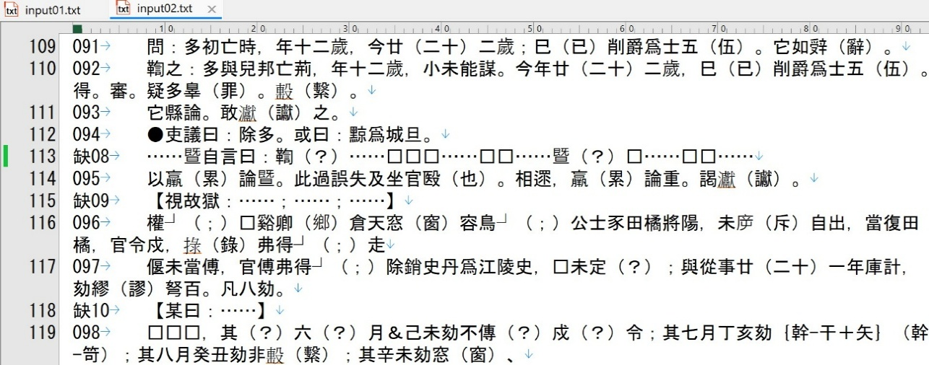
The text of the first edition is contained in the text file “input02.txt” and put in the second place of the ordered list of file names to be collated by the script. (Figure 18).
Figure 18 Collation script input file example (first edition of the comparison)

The text of the revised edition is stored in the text file “input01.txt”, which is put on first place of the ordered list of file names and handled as the main witness (figure 19).
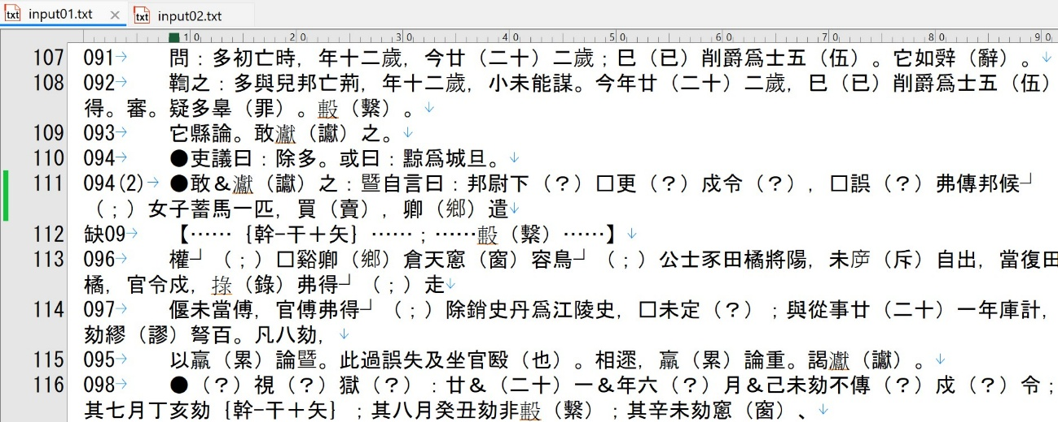
Figure 19 Collation script input file example (revised edition of the comparison, main witness)

For each input file, the script generates a sequence of slip numbers, reflecting the different slip arrangements. After comparing the sequences, the comparison module returns an output that states “equal” for the sub-sequences of “091” to “094”, “缺09” to “097”, and for “098”; “replaced by 缺08 and 095” for (the subsequence) “094(2)”, and “replaced by 缺10” for “095”. For the slips 091 to 094, slips 缺09 to 097, and slip 098 (along with several subsequent slips), identical slip IDs are observed at identical positions (I). Hence, the IDs of both witnesses are added to the @source attribute of the <p> element containing the pertinent slip text within the main text body.
The slip ID “095” is observed in both witnesses, but at different positions (II). Only the witness ID of the main witness is added to the @source attribute of the pertinent <p> element within the main text body. The witness ID of the second witness is appended to an <rdg> element in an apparatus that is created to record its replacement by the slips 缺08 and 095 and linked to slip 094(2). As a slip text for the slip 095 is already given in the main text body, its content is merely referred to through a @copyOf attribute.
The slip IDs “094(2)”, “缺08” and “缺10” are exclusively found in only one of the witnesses each (3b). For the slip ID “094(2)” that means the slip ID is found in the main witness only (III); the slip IDs “缺08” and “缺10” are found only in the second witness (IV). Hence, the witness ID of the main witness is stored in the @source attribute of the <p> element containing the slip text of “094(2)” within the main text body; the existence of the slips “缺08” and “缺10” in the second witness is recorded in the apparatuses within the <back> element, linked to slips “094(2)” and “095” respectively.
The main text body part is displayed in figure 20.

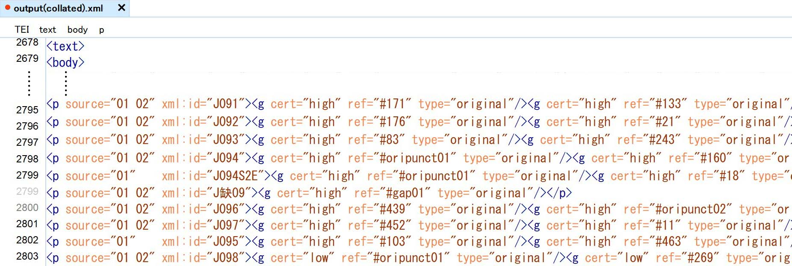
Figure 20 Example main text body after automated collation
The back matter part is shown in figure 21.
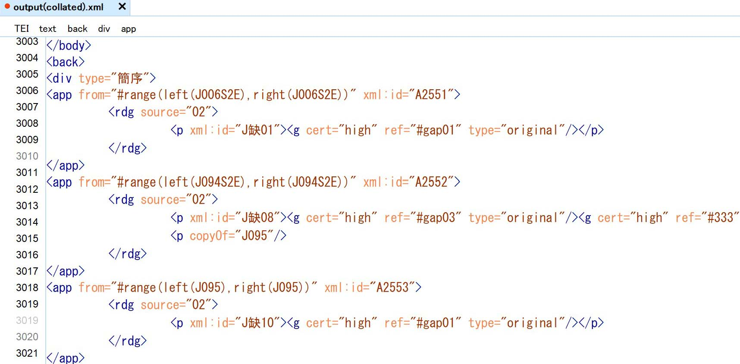
(Slip arrangement)
(Link to slip text 094(2) in the main body)
(Link to slip text 095 in the main body)
Figure 21 Example back matter after automated collation
The second part of the current experiment aims at comparing the main bodies of text, slip by slip. The slip texts were not compared according to the order of appearance in the respective witnesses, but for each pair of slips with identical IDs, notwithstanding the position of the specific slips within the entire slip arrangement. The slip texts were also stripped off of most of their traditional markups. As stated earlier, the goal is to simplify the individual comparison processes by preselecting comparison objects according to their basic information load or the layer of information they belong to. For instance, differences have been detected for slips 032, 042, and 044. Stripping the slip texts off their markups, the text to be compared looks like the following table 5.
Table 6 Comparison example main text body without any markup
Slip 032
Input01 | 好□□□部中即令覆□驩求盜尸等十六人追┘尸等產捕詣秦男子治等
Input02 | 好□□□部中即令獄史驩求盜尸等十六人追┘尸等產捕詣秦男子治等
Slip 042
Input01 | □□□□□□攻盜┘京州降爲秦乃殺好等疑尺等購●𤅊固有審矣治等審秦人殹尸
Input02 | □□□□□□攻盜京州降爲秦乃殺好等疑尺等購●𤅊固有審矣治等審秦人殹尸
Slip 044
Input01 | ●廿三年四月江陵丞文敢𤅊之廿三年九月庚子令下劾𢮑江陵獄上造敞士五
Input02 | ●廿三年四月江陵丞文敢𤅊之廿三年九月庚子令下劾𢮑江陵獄上造敞┘士五
Even for the human eye, this comparison is an easy game. With regard to slip 032, the ninth and tenth characters “覆□” found in input01.txt are replaced by “獄史” in input02.txt; the original punctuation mark “┘” that is found on slip 042 at position 9 in “input01.txt” is deleted in “input02.txt”; finally, for slip 044, the same punctuation mark is added between the thirtieth and the thirty- first character of “input01.txt” by “input02.txt”. The same comparison result is documented in “output(collated).xml” as in figure 22:
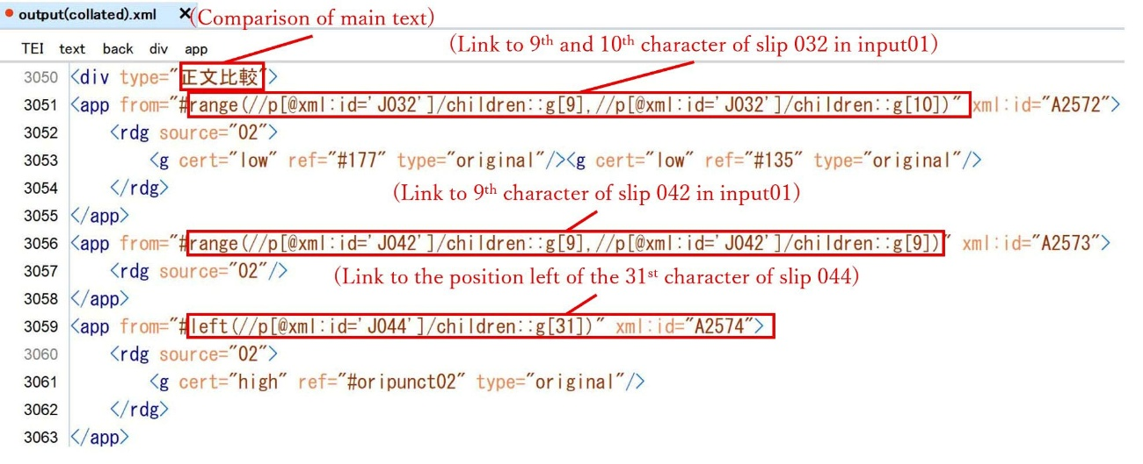
The “<g cert="low" ref="#177" type="original"/>” and “<g cert="low" ref="#135" type="original"/>” in the first apparatus stand for the characters “獄” and “史” that replaced the 9th and 10th characters of slip 032 (= “覆□”) ; the empty element “<rdg source="02"/>” in the second apparatus indicates that the corresponding character in input01 (“┘”) has been deleted in source 2; the link to the position instead of a subsequence of characters in the third apparatus signals that the following reading found in input02.txt is not a replacement of characters but an insertion at the specified position.
Figure 22 Example result of main text body comparison
As text is a sequence selected from the set of characters allowing repetition, it frequently proves challenging to discern the editorial intervention that caused the differences observed between different texts. Certain comparison modules compare the shortest path of editorial changes from one text to the other; some modules search recursively for the longest overlapping and interpret the characters in between as changes. Whatever the rationale may be, automated comparison results occasionally fail to align with our human understanding. Though the author did not encounter such a scenario during the current experiment, encoding based on automated text comparison should always be prepared to check and reinterpret carefully the given comparison results.
Correspondingly, the final stage of the current experiment was the automated conversion of the collation results into annotated texts in HTML format, allowing for straightforward inquiry into the reliability of the collation process. Conversion was again conducted by XSL transformation. Figure 23 shows the main text fragment of the slips 094(2) to 098. The first line assigns the case that starts from slip 094(2) with a title, which is provided by the editor. The slip arrangement and the transcription follow the main witness. The transcription covers only two sorts of traditional markups: the boxes indicating supplementary transcription based on context and the question marks in parentheses expressing uncertainty.
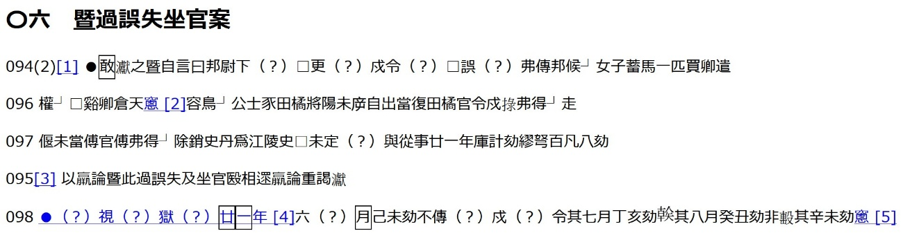
Figure 23 XSL-transformation example of collated xml-file (main text body)
Numbers in square brackets are annotation numbers. Links guide the reader to the annotations stored at the end of the case. Figure 24 shows the Japanese version:
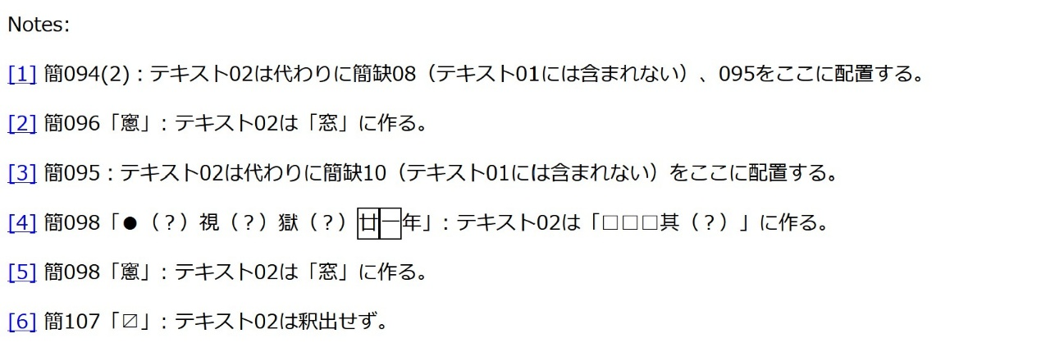
Figure 24 XSL-transformation example of collated xml-file (annotations, Japanese version)
Except for a language switch to Chinese, figure 25 displays the same contents:
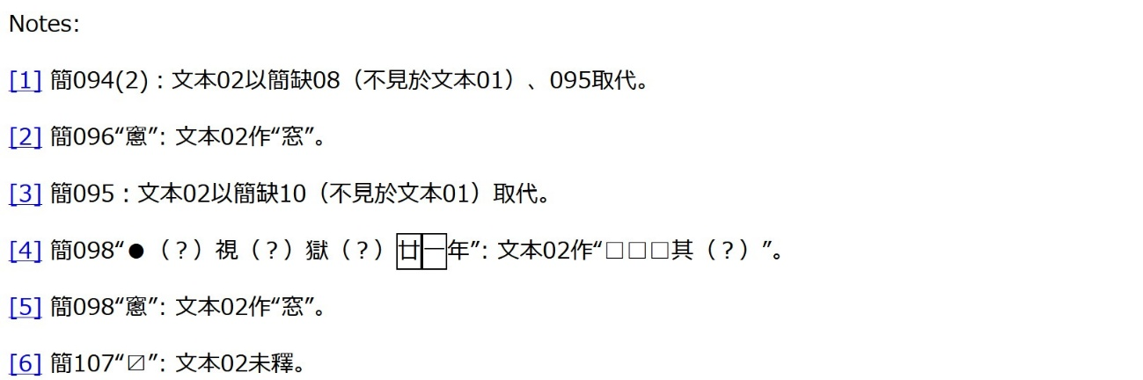
Figure 25 XSL-transformation example of collated xml-file (annotations, Chinese version)
Figure 26, in addition to displaying the same content, features the notes of an extra case documented on slips 137 to 141. These are in English now.
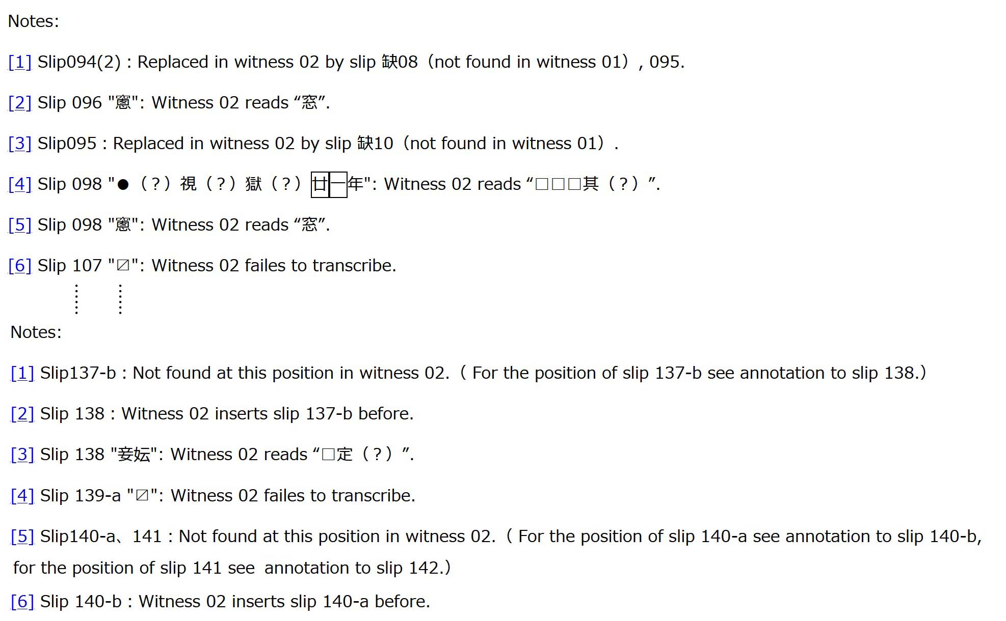
Figure 26 XSL-transformation example of collated xml-file (annotations, English version)
- The encoding and redefinition of characters
  - What is a Chinese character?
As a morphographic writing system, Chinese characters represent units of meaning, sometimes entire words, sometimes meaningful parts of words, in short morphemes. For a long time, this led to the misunderstanding that Chinese characters are ideographs, i.e. graphic characters that directly indicate or express meaning. Actually, the morphemes and not the characters carry the meaning even in Chinese. In this regard, Chinese characters essentially function like any other script worldwide: they are a set of symbols that represent or record language. Hence, an accurate description of Chinese characters cannot avoid the question of the connection between characters and language.
Traditionally, this connection was conceived as the trinity of shape (xíng形), sound/reading (yīn音), and meaning (yì義). According to Morioka Tomohiko,

“Chinese characters (kanji/hànzì漢字) can be considered morphographic characters as one character corresponds to one morpheme in classical Chinese. Hence, they were traditionally analyzed and arranged based on the pairing of or the correspondence between various elements related to shape, sound and meaning."

It is noteworthy that Morioka limits his argument to morphemes in “classical Chinese古典中國語”. Even though the definition of “classical Chinese” is not readily apparent, a reference to language is indispensable for analyzing a set of symbols that is presumed to represent language. In my view, Morioka’s reference to “classical Chinese” could be seen as appealing to a common tradition shared by at least modern Japanese, Korean, and Chinese. In Japanese as well as in Korean, there still exists a set of readings for Chinese characters that can, just like modern Chinese readings, be more or less accurately traced back to the systematic and standardized description of medieval Chinese sounds in the Guǎngyùn廣韻, a comprehensive Chinese rhyme dictionary compiled in the early 11th century. Most of the meanings of morphemes bound to these “common” readings in modern Japanese and Korean dictionaries derive from or are strongly influenced by the standardized understanding of Chinese characters displayed in the Kāngxī zìdiǎn康熙字典, a standard dictionary of Chinese characters edited under the patronage of the fourth ruler of the Manchurian Qing empire.
To my understanding, this common tradition, though fuzzy as it might be, was the foundation that facilitated the integration of several national codes representing Chinese characters into one single character code, the Unicode Standard. The Unicode Consortium refers to this common ground as follows:

“For many centuries, written Chinese was the accepted written standard throughout East Asia. The influence of the Chinese language and its written form on the modern East Asian languages is similar to the influence of Latin on the vocabulary and written forms of languages in the West. …… The evolution of character shapes and semantic drift over the centuries has resulted in changes to the original forms and meanings. …… Still, the identical appearance and similarities in meaning are dramatic and more than justify the concept of a unified Han script that transcends language.”

Speaking of “transcending languages” is, of course, highly problematic. It contradicts both Morioka’s limitation to “classical Chinese” and the consortium’s own understanding of characters:

“The difference between identifying a character and rendering it on screen or paper is crucial to understanding the Unicode Standard’s role in text processing. The character identified by a Unicode code point is an abstract entity, such as “LATIN CAPITAL LETTER A” or “BENGALI DIGIT FIVE”. The mark made on screen or paper, called a glyph, is a visual representation of the character.”

Without question, the distinction between characters and glyphs does indeed clarify the dependency of characters on language. The expressions “CAPITAL LETTER A” and the “DIGIT FIVE” in the quotation would not make any clear sense without the modifications “LATIN” and “BENGALI”. The same glyph can represent a completely different character in a different language context.
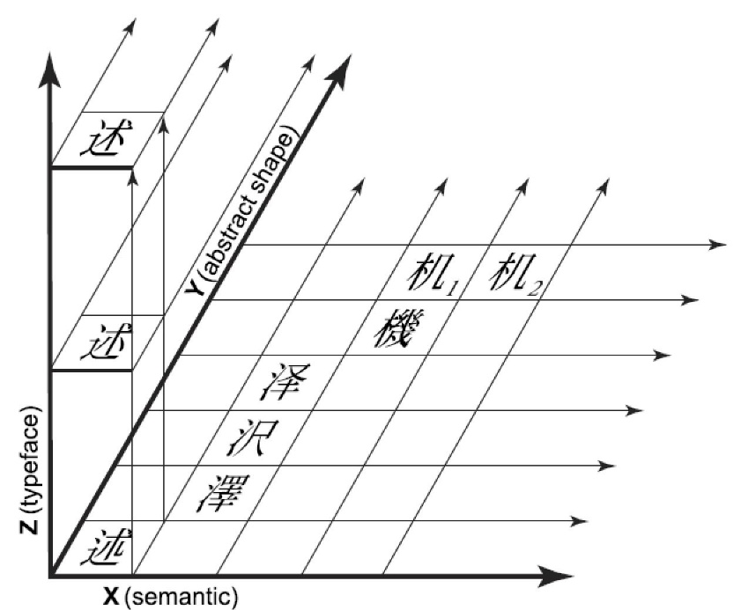
The Unicode Consortium tries to define Chinese characters, or “unified Han ideographs”, by shape and meaning, excluding the reading element. Considering the shared phonetic origins, this exclusion is neither necessary nor fundamentally flawed. This phonetic feature is inherent to the common tradition that underlies the integration of various national standards. The defining readings of the characters are interconnected through their relation to the Guǎngyùn sounds. Omitting this inherent connection only makes the definition of a character overly simplistic.
Based on a three-dimensional conceptual model, the Unicode Consortium defines characters by shape and meaning. The model assigns “written elements” three primary attributes: semantic (meaning, function), abstract shape (general form), and actual shape (instantiated, typeface form), as depicted in figure 27. Regarding the three dimensions, the following is said:
Figure 27 The Unicode Three-Dimensional Conceptual Model

The semantic attribute (represented along the X axis) distinguishes characters by meaning and usage. Distinctions are made between entirely unrelated characters such as 澤(marsh) and 機(machine) as well as extensions or borrowings beyond the original semantic cluster such as 机₁ (a phonetic borrowing used as a simplified form of 機) and 机₂ (table, the original meaning).
The abstract shape attribute (the Y axis) distinguishes the variant forms of a single character with a single semantic attribute (that is, a character with a single position on the X axis).
……
Z-axis typeface and stylistic differences are generally ignored ……

The explanation about the semantic attribute sounds as if the Unicode Standard would distinguish 机₁ and 机₂, which, of course, is not true. The haracters 机₁ and 机₂ share the same code point “673A”. Taking practical considerations into account, this is reasonable for the Unicode Standard, but it means that Unicode discerns “writing elements” merely based on abstract shapes as all characters that differ in meaning but overlap in shape are unified into one single code point. In other words, the Unicode Consortium merely provides a list of abstract shapes or glyphs, leaving the question of characters open.

  - Defining Chinese characters by sound and meaning
From a linguistic perspective, the focus of character analysis within the context of a morphographic script lies with the morphemes. These morphemes consist of sound and meaning, often concealed behind constantly shifting shapes. This perspective is literally the opposite of the shape-centered approach of the Unicode standard.
With regard to this perspective, Qiú Xīguī裘錫圭 (1935-2025)’s argument that the Chinese script ought not to be understood as a morphemic or morphographic script might be instructive. In the Chapter Two “The Nature of Chinese Characters” of his groundbreaking book “Chinese Writing”, Qiú strives to develop his own comprehensive perspective on the nature of Chinese characters. In his final argument, he offers additional evidence for its accuracy by comparing it with morphemic views on Chinese characters.
According to Qiú, the Chinese script is a set of characters that employ three different types of symbols: semantic symbols (=yìfǔ意符), phonetic symbols (=yīnfǔ音符), and signs (=jìhào記號). Regarding “signs”, Qiú argues that:

“(I)n the process of the development of the Chinese script, due to changes in graphic shape, phonology and semantics, many semantic and phonetic symbols lost their semantic and phonetic functions and became signs.”

He provides the definition of “signs” as “arbitrarily fixed symbols that had no inherent relationship to the object represented.” The wide use of signs is considered a rather late phenomenon. Hence, Qiú assumes the development of the Chinese script from a strictly “semanto-phonetic script” to a “late semanto-phonetic script” that incorporates considerable amounts of signs.
For an accurate understanding, it is indispensable to mention that Qiú distinguishes two different levels of symbols as follows:

“Characters are symbols representing language. But characters themselves taken as language representing symbols and the symbols used by the characters are concepts belonging to two different levels.”

The terms “character” and “symbol” are renderings of the Chinese words “wénzì文字” and “fúhào符號”, respectively. In this sentence, Qiú still uses the term “symbol” in a two-fold manner, but two paragraphs later he makes an important clarification: “For the sake of clarity, the symbols used by a character will be called graphic symbols (=zìfǔ字符).” Qiú dedicates himself throughout the book to adhere to this distinction. Characters are symbols representing language whilst themselves deploying graphic symbols. The “semantic symbols (=yìfǔ意符)” and “phonetic symbols (=yīnfǔ音符)”, which are the core pillars of his theoretical framework of a “semanto-phonetic script”, are, of course, exponents of “graphic symbols”. They help characters fulfill their role as symbols representing language.
Raising some of Qiú’s examples may foster better understanding. Qiú exploits the character “huā花 (flower)” to illustrate the difference of the two levels of symbols.

“(T)he Chinese character “花” huā is a symbol of the Chinese word｛花} "flower"; "艹" (the grass component, originally written “艸”, the old graph for căo “grass”) and “化” huà are the symbols used in writing the character “花”（a phonogram: “艹” is the signific and “化” the phonetic）.”

In this case, the character is a “composite character (=hétǐ zì合體字)”. This means the character is composed of two components, each being understood as a graphic symbol. Hence, the distinction between the character as a symbol representing a Chinese word and the graphic symbols comprising this character is easy to comprehend.
The matter gets more intricate when the discussion turns to “non-composite characters (=dútǐ zì獨體字)”. Qiú presents the example of the character “rì日” , involving its very early writing form:

“(T)he ancient character （日）when viewed as a symbol of the Chinese word｛日} rì “sun” is a graph possessing both a meaning and a sound; looked at as a symbol for the character “日” rì, then it is merely a pictographic symbol with a shape resembling the sun.“

For Qiú, even “non-composite characters” are “composed” of graphic symbols. The difference between “composite characters” lies solely in the number of components. The former has two or more components, whereas the latter has only one. In the case of the character “r ì日”, or 日 is a pictographic symbol with a semantic load deriving from its sun-like shape; only when this graphic symbol composes the character “日” representing the word “rì”, it acquires a reading. We could also conclude that the word level includes both reading and meaning; the graphic symbol level often includes only one of both.
Interestingly, loangraphs (=jiǎjiè zì假借字) can make use of entire characters as phonetic symbols, no question whether the borrowed characters are “non-composite characters” or “composite characters”. With regard to the ancient character “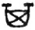(= 其)” and the modern character “花“, Qiú explains as follows:

“(W)hen the semantograph standing for {箕} jī "winnowing basket” was used to represent the modal particle｛其} qí, the two words｛箕} and {其} were not at all related semantically. Another example is the modern use of the phonogram｛花} huā "flower" to represent the verb｛花} huā "to spend (money)." While both of them are pronounced huā, they are totally unrelated semantically. Therefore, even though was originally a semantograph and “花” was a phonogram, when they are borrowed to write the modal particle｛其} and the verb {花}, they function purely as phonetic symbols.”

What is the point of taking the pain to discern these two levels of symbols? In my view, Qiú did not clearly specify the objective of this distinction, but his discussion on the concept of morphemic or morphographic script clarifies his stance.
Qiú’s argument about the relationship between Chinese characters and morphemes is twofolded. On the one hand, he admits the existence of morphemic features in the Chinese script, taking morphemic theories of the Chinese script as perspectives fundamentally different from his own approach, which is focused on “graphic symbols”. On the other hand, he argues that, even when changing the perspective, morphemic theories should be amended to “morphemo-syllabic script”, pointing to words that are comprised of two or more syllables and cannot be broken down into one-syllable morphemes. In these cases, no single character in the string of characters expressing the pertinent word can represent an entire morpheme; any single character merely refers to a phonetic fragment of the morpheme, a syllable. In other words, his second argument is centered on the phonetic function of loangraphs, whilst admitting that other types of characters, such as semantographs, etc., could be considered morphemic graphs. Let us first see how he puts this second argument:

“(N)on-composite, quasi-composite and composite semantographs, as well as sign graphs and semi-sign, semi-semantographs, can all be viewed as morphemic graphs. However, the phonetic symbols of the Chinese script, although they are all written with ready-made graphs which were originally morphemic symbols, ought to be viewed as symbols expressing syllables; ……In the case of those loangraphs which record transcribed foreign words of two or more syllables, it is perfectly clear that they express the nature of the syllabic structure of morphemes. For example, the four characters "達魯花赤" dálǔhuāchì which were borrowed in the Yuan dynasty to write the Mongolian title darugaci "governor, keeper of the seal," are clearly all used as syllabograms. Loangraphs used to write native Chinese binomes like "倉庚" cānggéng "name of a bird" and "猶豫" yóuyù "hesitate"（see Sec. 9. 3）also clearly are employed to express syllabic structure.”

The first argument of difference in perspective highlights the objective behind his emphasize on graphic symbols:

“The terms morphemo-syllabic script and semanto-phonetic script（or semanto-phonetic-sign script）are names given to the Chinese script looked at from different points of view. The former focuses on the level of linguistic structure represented by graphic symbols; the latter focuses on the semantographic or phonographic functions of graphic symbols. These two terms can coexist.”

In my view, the focus on the functions of graphic symbols that comprise the characters is nothing else than an inquiry into the question of how Chinese characters have been created or deployed for the representation of certain features of language. For instance, the rationale behind the character “日” representing the word “rì (= sun)” is explained as because the graphic symbol “” is a pictorial representation of the sun, establishing a semantic link to the word “rì” but no phonetic link. In a similar manner, the character “花” can represent the word “huā (=flower)” because of the semantic link by the signific “艹/艸” and the phonetic link by the phonetic “化”. The same character “花” can represent the word “huā (=to spend)” because of the phonetic link established by the loan of the entire character as a single phonetic symbol.
These inquiries bear some resemblance to traditional Chinese philology, yet Qiú’s unwavering focus on “words” and “morphemes” strikes me as remarkably innovative. To be precise, Qiú‘s methodology fully integrates the morphemic theory, while also attempting to address traditional inquiries. Within this two-fold approach, the focus on the linguistic layer of “words” and “morphemes” clearly marks the linguistic turn in Chinese paleography, which had been carefully prepared by Táng Lán唐蘭 (1901-1979) and then accomplished by Qiú. It marks a definite departure from the worn-out notion of ideographs that directly convey meaning, as broadly seen in the work of Shirakawa Shizuka白川静 (1910-2006) or still present even in Chén Mèngjiā陳夢家 (1911-1966)’s Zhōngguó wénzì xué中國文字學.
Having experienced the linguistic turn, the focus on “words” and “morphemes” might sound even banal to us. But regarding the Chinese script, this can be an extremely challenging journey as constantly changing shapes easily obscure the linguistic layer from our sight. Qiú‘s brilliant analysis on the semantic connection of the character “shǐ矢 (usually ‘arrow’)” in Ode 45.1 “之死矢靡它” to the well-known character “chén陳 (=to display, to state) demonstrates how subtle linguistic connections often go unnoticed. At the same time, this linguistic layer, the unity of sound and meaning, is just what the character definition of the Unicode is lacking. This is also what we must focus on for a more historical comprehension of Chinese characters.

  - The challenges of paleographic understanding of characters
The greatest challenge for a paleographic understanding of characters is the reconciliation of the unity of sound and meaning, i.e. words or morphemes, with the shape of characters. Qiú (1988) devotes three entire chapters to explore the intricate relationship between words or morphemes and the character shapes: Chapter 10 “Allographs, Homographs, and Synonymic Interchange”, chapter 11 “Graphic Differentiation and Consolidation”, and, finally, chapter 12 “The Intricate Relationship Between Graphic Form and Sound and Meaning”. If we take the last chapter 13 “The Systematization and Simplification of Chinese Script” as a discussion on the endeavors in the People’s Republic of China to unravel this intricate relationship, four of the entire thirteen chapters are dedicated to this topic.
This, of course, is far too complex to unwind here. It must suffice to say that the bulk of discussions continues to oscillate between shape and morphemes; different shapes are brought together based on the unity of sound and meaning, and identical shapes are discerned based on the difference in the sound and/or meaning of the words they represent. Only the historical-linguistic context varies, and with it Qiú’s interpretation of the specific relationships. Qiú’s strong interest in how certain characters happen to represent certain words or morphemes further increases the complexity of the discussion as well as the possibilities of disagreement on certain interpretations.
Boiling it down to a phenomenological level, the shapes of Chinese characters change much faster in time and space than the morphemes they represent. The same morpheme can be represented by different shapes at different times or locations. A crucial role of paleography is to trace and keep records of these historical changes. For instance, Ōnishi Katsuya gathered the different writings of the word expressing the verb “to cast” on weaponry during the Warring States period (453/403-221 BCE). Except for the State of Yān燕 using a word cognate to the modern “wéi爲”, the others used cognates of the modern “zào造”. The various shapes of the character “zào造” are displayed in table 7:
Table 7 Warring State Period shapes of the character “zào造”
 | Qín秦 | Qí齊 | Chǔ楚 | Wèi魏・Zhào趙 | Hán韓 | Sòng宋
造 | ○ | ○
艁, 鋯 |  | ○
𢽍, 郜, 俈 |  |  | ○
𬥘 |  |  |  |  |  | ○
𫿜 |  |  |  | ○ | ○
𪯓, 棗 |  |  |  |  | ○

These amount to ten allographs for a word that is still in use in modern Chinese. To my own surprise, I could find all ten being included within the Unicode character set, which, without a doubt, is a huge practical benefit. Given their distinct shapes, Unicode treats them as separate characters, which makes the Chinese script set significantly more complicated and convoluted than strictly needed from a linguistic perspective.
Shào Yǒnghǎi 邵永海 developed a concept that from the very beginning has been minted in order to decrease such complexities and intricacies. This concept is called “zìwèi字位” in Chinese and could be translated as “character position”. “Position” appears to refer to a fixed position within the morphemic space represented by the Chinese script.
Like Qiú Xīguī, Shào focuses on words or morphemes, but he stops at the stage of identifying the morphemes that are hidden behind the shapes and bundles identical morphemes into “character positions”, irrelevant to the variety of shapes that might represent them. In other words, Shào turns the perspective back to the morphemic writing aspect in order to reach a clearer picture of language features that are represented by characters but also somewhat concealed by the variety of their shapes.
Shào displays strong interest in the digital processing of characters in a linguistically meaningful manner. He points out repeatedly that different normative frameworks actually comprise unnecessary obstacles to this objective. For him, the impedimentary effect of normative frameworks can be witnessed in modern encoding of characters as well as in the historical changes of character shape throughout the three thousand and more years of Chinese writing history. One example of the impediments of modern character norms involves the character “guī龜 (tortoise, turtle)”, whose “formal/correct shape (=zhèngtǐ整體)” varies among East Asian states and regions:
Table 8 Various normative shapes of the character guī龜
龜 | 龜 | 龜 | 龜 | 龜
China | Taiwan | Hong Kong | Japan | Korea

Unicode reserves three code points for these five normative character shapes. “U+F907 /63751” for the Hong Kong version, “U+F908/ 63752” for the Korean version, and “U+9F9C/ 40860” for the other three shapes, which have been displayed in this paper with the help of different fonts. Similar discrepancies in normative requirements for character shapes are pointed out for the following string of allographs:

裏-裡；黃-黄；涙-泪；恥-耻；幫-幇；牀-床；昇-陞〔升〕；穽-阱；徑-逕；舉-擧；貍-狸；犁-犂；弔-吊；匯-滙；群-羣；剋-尅；妬-妒；荊-荆；够-夠；諮-咨；眾-衆；歎-嘆；啟-啓；髕-臏；腳-脚；汙-污

Shào refers to these examples and states that “character codes …… do not encompass information that connects allographs or other interchangeable graphs.” According to him, these “differences in character shape directly influence the stability and authority of digitized dictionary contents.” These problems are well-known, and many search engines are already capable of reconnecting allographs that have been separated by different code points within the Unicode standard. However, Shào claims the need for a linguistic solution to such problems that also includes the longer historical development of the Chinese script. In his view, the definition of “character positions” by common reading and meaning is a more reliable method of overcoming the intricacies caused by endless shape changes:

“After joining, every character position takes charge for multiple shapes, forming a character family. One character family holds the different shapes of one character position, such as Oracle bone inscription shapes, bronze inscription shapes, seal script shape, clerical script shapes, and all sorts of allographs and synonymic interchangeables. Since an effective connection is established within the character families, search results include all shapes of the same character position, no question which shape is used for the query.”

Relinking different character shapes through their representation of common morphemes appears to be the main objective behind Shào’s proposal of the concept of “character position”. In this regard, the concept could facilitate the handling of paleographic phenomena such as the various shapes of the character “zào造” gathered by Ōnishi.
However, the concept can also be utilized in the opposite direction, i.e. it can also help discern homographs and other shape overlapping phenomena. As Shào’s argument does not reach this far, the author will try to apply the concept to some overlapping phenomena frequently seen in paleographic material from the Qin and Han period.
The glyph “灋” is commonly known as the ancient form of the character “fǎ法 (=penalty, law)”. Xǔ Shèn許慎 (30/58 – 121/147 CE)’s Shuō wén jiě zì説文解字 records it as the seal script shape, stating that the current writing simplifies it to “法”. In legal literature from the late Warring States period, the same glyph represents two different words cognate to modern “fǎ法” and “fèi廢” respectively. The bamboo slips excavated from Tomb 11 in Shuihudi, Hubei province, entail an official notice by the prefect of the Nán province. On the slips 3 to 4 of the document, the same glyph is used for both “fǎ法” and “fèi廢”:

Now, the statutes on penalties are furnished. But the officials and the ordinary people do not adhere to it, …, that amounts to abandoning the clearly stipulated penal law.
今灋（法）律令已具矣，而吏民莫用，…，是卽灋（廢）主之明灋（法）殹（也）。（睡虎地11号秦墓竹簡『語書』簡003-004）

Be aware that the original character “廢” is, based on the semantic difference, regularized to “fǎ法” and “fèi廢” respectively.
A wooden tablet excavated from the Liye-site in Longshan, Hunan province, shows that, as a part of the character unification under the First Emperor of the Qin, the function of this glyph was split into two; the function of representing the word cognate to modern “fèi (=abandon, abolish)” was delegated to the newly created glyph “廢”. Figure 28 displays an image of the entire tablet. Here, we only cite three items:

“Yǒu酉 (=tenth of the twelve Earthly Branches)” remains as was, “jiu (=alcoholic drink) is changed to “酒”.
酉如故更酒。
“Fǎ灋” remains as was, “fèi guān (=dismissal from office)” is changed to “廢官”.
灋如故更廢官。
“Shǔ鼠 (=rat) remains as was, “yǔ rén(=to give sb, to bestow sb)” is changed to “予人”.
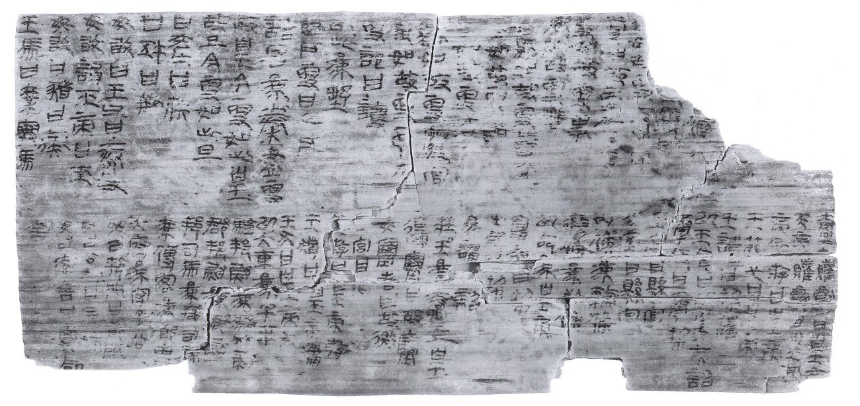
鼠如故更予人。
Figure 28 Wooden tablet from the Liye-site connected to the script unification of the Qin
After the script unification, “fǎ灋” and “fèi廢” distinctly refer to two separate words. Even before the unification, the semantic difference is significant. It would hardly make sense to combine all occurrences of the glyph “灋” into a group of characters connected to the word “fǎ灋”. A more reasonable option would be to draw the line based on the semantic and phonetic difference that we asserted in the form of different regularizations in the transcription. That would mean that some instances of “灋” gather the group of characters connected to the modern character “fǎ法”, while others join the group of “fèi廢”. This grouping could be easily represented by Shào’s concept of “character position”. “Fǎ法” and “fèi廢” represent two different character positions. Characters that can be associated with either position are considered members of the same character family, regardless of which glyph was employed in the original text.
The next example is even more intricate. According to Shuō wén jiě zì, the character “zuì最 (=most, summary, etc.)” is composed of the graphic symbols “mào冃 (=cap)” and “qǔ取 (to take)”. In popular writing, the two horizontal strokes inside the component “mào冃” are often abbreviated, reducing the entire character to the shape of “冣”. This makes this character a homograph to the character “jù冣 (to accumulate)”, which according to Shuō wén jiě zì is comprised of “mì冖 (cloth cover)” and “qǔ取”. In his annotation to Shuō wén jiě zì, Duàn Yùcái段玉裁 (1735-1815) argues that the reading and meaning of “jù冣” are identical to “jù聚”. Hence, the character is generally considered an allograph to “jù聚”.
 | Yǔshū語書 | Qínlǜ shíbā zhǒng秦律十八種 | Rìshū jiǎ zhǒng日書甲種
Zuì最 | 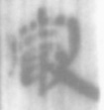（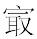）  13 | 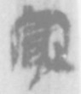 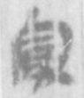（）  013 014 | 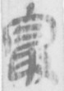（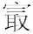）  056背參
Jù冣 | － | － | 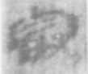 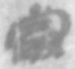 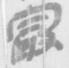（）  005正貳／015背壹／016背壹
The tendency of omitting the two horizontal strokes inside the “mào冃” component of “zuì最” has already been observed within the clerical Qin script at the end of the Warring States period, and has caused some scholars to argue that the characters “zuì最” and “jù冣” were merged during this time. Indeed, the writing of these two characters is confusing, but they are not truly merged. They are distinguished in a relative sense from each other by writing different numbers of vertical strokes. Table 9 gathers all instances of “zuì最” and “jù冣” that can be found in the texts from Tomb M11 at the Shuihudi-Site in Yunmeng, Hubei. Comparing these instances, the shape “” is used in the Yǔshū語書 and Qínlǜ shíbā zhǒng秦律十八種 to represent the character “zuì最”, and in Rìshū jiǎ zhǒng日書甲種, it represents the character “jù冣”. This phenomenon indeed gives the impression that the two characters are at least confused. However, there is one instance of the character “zuì最” in the Rìshū jiǎ zhǒng日書甲種, which is written as “”, adding one more vertical stroke in comparison to the character “jù冣” in the shape of “”. In other words, the scribe of the text clearly felt the necessity to distinguish these two characters, and did so by increasing or decreasing the number of vertical strokes.
Table 9 The relative distinction between “zuì最” and “jù冣” in the Shuihudi tomb 11
In this case, Shào’s concept of “character position” could be helpful again. No question whether the shape is written as “冣”, “㝡”, “”, or “”, characters that can be identified as representing the same word “zuì最” should be associated with one character family, sharing the same character position within the Chinese writing system; characters representing “jù冣” belong to a distinct character family, occupying a completely different position within the writing system.
Partly overlapping in component shape is also observed quite frequently in the clerical script during the Qin and the Han. Well known exponents are the components “聿” and “隶”, “彖” and “录”, “辶” and “廴”. Some transcribers view these interchanges of components as mistakes. If the character “dài逮” is written with the components “聿” and “廴”, they transcribe “建〔逮〕”. But these writing habits apparently have not been treated as mistakes by contemporaries; it was their customary way of writing. They were aware of the words or morphemes their script represented. Hence, our task should be to identify these words or morphemes and not to correct their writing habits. This is possible by accumulating different shapes to character families based on their position in the writing system, or, plainly, the words they represent.

  - A new way of TEI-encoding of characters
In the previous sections, the author tried to outline what it means to encode characters rather than glyphs. Now, we must find a way to express these ideas using TEI- elements. Actually, the <charDecl>, a member of the gaiji module, already distinguishes the elements <glyph> and <char>. Once again, the author is compelled to acknowledge that the TEI-guidelines were prepared well, yet we users easily overlooked what this difference means in the context of Chinese writing. Below, I will attempt to employ the paleographic examples provided in the previous section to delineate how to encode Chinese characters using TEI.
First, each character possesses an abstract shape. The <glyph> element can be utilized to document the shape. The basic syntax should be one <glyph> element for one shape, with an @xml:id attribute assigning an identifier to it. Within the <glyph> element, the <mapping> element could take charge of the task of defining shapes. This would look like this:
<glyph xml:id="glyph-ID"><mapping>shape</mapping></glyph>
Secondly, each character represents a word or morpheme. The word or morpheme can be identified through the synthesis of its sound and meaning. For the description of these two features, we primarily utilize the readings of characters as depicted in the Guǎngyùn廣韻, alongside with the gloss given in the same book. If a character is not documented in Guǎngyùn廣韻, we need to resort to the readings found in later dictionaries, but as a rule of thumb, a character not recorded in the Guǎngyùn廣韻 should raise alarm within the context of paleography. With high probability, our interpretation of the character is inaccurate. Hence, this paper will not go into detail in this regard. For the glosses, reinforcement should be sought from early annotations and dictionaries. Glosses later than the 3rd century CE should be again handled with precaution. Judging from excavated language material, the Chinese language changed dramatically during the two Han dynasties. Accurate knowledge about early Chinese that still circulated in academic circles got lost during the 3rd century.
This character's linguistic representation aligns with the unit that combines sound and meaning. This unit gives the character a fixed position in the script system, a “character position” according to Shào’s theory. For illustrative purposes, we could give a modern representation of this position in the form of a character. The overall syntax for a character definition would then look like this:
<char xml:id="char-ID">
<mapping type="sound guǎngyùn">fǎnqiè反切</mapping>
<mapping type="gloss guǎngyùn ">a gloss</mapping>
<mapping type="early gloss">a gloss</mapping>
<mapping type="character position">a modern character</mapping>
<note>A note if necessary</note>
</char>
Lastly, we would need to search for a method to link characters within the main text to the glyph and character definitions. Within the <charDecl> element, each <glyph> and <char> element carries a unique ID, stored in the @xml:id attribute. These can serve as reference benchmarks. The characters in the main text are denoted by <g> elements, as outlined in chapter 3. <g> elements can carry @ref and @ana attributes. These facilitate links to the glyph and character definitions. While glyph references can be established automatically, as demonstrated previously, character references still need scholarly scrutiny. Hence, it appears to be reasonable to use the @ref attribute for glyph reference and the @ana attribute for character reference. A character within the main text would then look like this:
<g ref="#glyph-ID" ana="#char-ID">
For demonstration, we will encode the few paleographic instances mentioned in the previous section. The glyph “灋” that represents the word “fǎ法” could be distinguished from the same glyph representing the word “fèi廢” as follows:
Glyph definition:
<glyph xml:id="U28747">
<mapping>灋</mapping>
</glyph>
Character definitions:
<char xml:id="C0001">
<mapping type=" sound guǎngyùn">方乏切</mapping>
<mapping type="gloss guǎngyùn">則也</mapping>
<mapping type="gloss Shuō wén jiě zì">刑</mapping>
<mapping type="gloss Yùpiān（玉篇廌部）">刑</mapping>
<mapping type="gloss Yùpiān（玉篇水部）">法令</mapping>
<mapping type="position">法</mapping>
<note>……</note>
</char>
<char xml:id="C0002">
<mapping type=" sound guǎngyùn">方肺切</mapping>
<mapping type="gloss guǎngyùn">止也</mapping>
<mapping type="gloss Zhōulǐ Zhèngxuán Zhù周禮鄭玄注">猶退也</mapping>
<mapping type="gloss Yùpiān（玉篇广部）">退</mapping>
<mapping type="position">廢</mapping>
<note>……</note>
</char>
Character in main text:
“Fǎ灋（法）” = <g ref="#U28747" ana="#C0001">
“Fèi灋（廢）” = <g ref="#U28747" ana="#C0002">

Given that most glyph definitions have been standardized by Unicode, there's no need to reinvent the wheel. Therefore, the example used the decimal codepoint of “灋” (=28747) as glyph-ID. In fact, there is no necessity for glyph definition at all if the glyph is already part of the Unicode Standard. As every script can automatically encode and decode Unicode characters, the @ref attribute can use the code point directly as a reference. Only for non-Unicode characters, a glyph definition would indeed be necessary. Below follows an example of glyph definition for the non-Unicode shape of the characters “zuì最” and “jù冣” mentioned in the previous section:
:
<glyph xml:id="g0001">
<mapping type="IDS">⿳宀一取</mapping>
<graphic type="lìdìng隸定" url="gaiji0001.jpg"/>
</glyph>
:
<glyph xml:id="g0002">
<mapping type="IDS">⿳宀二取</mapping>
<graphic type="lìdìng隸定" url="gaiji0002.jpg"/>
</glyph>
Supposing that the character positions of “zuì最” and “jù冣” were assigned the character IDs “C0003” and “C0004” respectively, characters in the main text could reference this glyph definition as follows:
“zuì （最）” = <g ref="#g0002" ana="#C0003">
“zuì （最）” = <g ref="#g0001 " ana="#C0003">
“jù （冣）” = <g ref="#g0001" ana="#C0004">

Unfortunately, the author could not yet implement the ideas presented in this final chapter yet. The character definitions as well as the @ana attributes need to be created manually. This will require a considerable amount of time. The author looks forward to being able to showcase concrete outcomes at an upcoming meeting. Suggestions and criticism that can guide the author towards achieving this goal are highly valued.

- References
Hafner, Arnd Helmut (Táo Ān陶安, auth.), Zhū hànmín朱漢民 and Chén Sōngcháng陳松長(ed.) (2013), Yuèlù shūyuàn cáng qínjiǎn嶽麓書院藏秦簡 (Vol.3), Shànghǎi císhū chūbǎn shè上海辭書出版社
Hafner, Arnd Helmut (Sueyasu Ando陶安あんど) (2015), “Shinkan ni mieru’sai’ to ‘shū’ ni kansuru oboegaki秦簡にみえる「最」と「冣」に関する覚書”, in: HP of the Joint Research Project "The new boundary-crossing approach on Ancient Chinese Slip and Tablet Documents”, http://www.aa.tufs.ac.jp/users/Ejina/note/note15(Hafner).html .
Hafner, Arnd Helmut (Táo Ān陶安) (2016), Yuèlù qínjiǎn fùyuán yánjiū嶽麓秦簡復原研究, Shanghai: Shànghǎi gǔjí chūbǎn shè上海古籍出版社.
Hafner, Arnd Helmut (Táo Ān陶安) (2020), “Yuèlù shūyuàn qínjiǎn《wéiyù děng zhuàng sìzhǒng》dìèrlèi juǎncè ànlì bā zhì ànlì shíyī shìwén, zhùshì jí biānlián shāngquè嶽麓書院秦簡《爲獄等狀四種》第二類卷冊案例八至案例十一釋文、注釋及編聯商榷”, in: chūtǔ wénxiàn yǔ gǔwénzì yánjiū出土文獻與古文字研究 Vol. 9.
Hafner, Arnd Helmut (Táo Ān陶安) (2021), Yuèlù qínjiǎn《wéiyù děng zhuàng sìzhǒng》shìwén zhùshì（xiūdìng běn）嶽麓秦簡《爲獄等狀四種》釋文注釋（修訂本）, Shanghai: Shànghǎi gǔjí chūbǎn shè上海古籍出版社.
Hafner, Arnd Helmut (2023). “The State of Research in Early Chinese Legal History: A Review of Two Important Recent Annotated Translations in English”, in: Bamboo and Silk, 6(1), 103. https://doi.org/10.1163/24689246-20230031.
Hafner, Arnd Helmut (Táo Ān陶安) (2025), “ TEI wénběn biānmǎ, zìdònghuà wénběn bǐjiào yǔ diànzǐ xiàochóu xué文本編碼、自動化文本比較與電子校讎學,” in: (Conference proceedings) Běijīng dàxué dì sìjiè gǔdiǎn xué guójì yántǎo huì: quánqiú shìyě xià de Zhōngguó gǔdiǎn xué lùnwén jí北京大學第四届古典學國際研討會——全球視野下的中國古典學論文集.
Hafner, Arnd Helmut (Táo Ān陶安) (2025), “ Wénběn biānmǎ yǔ jiǎndú xué: xúnzhǎo zhǐzhāng shídài yǔ AI shídài de qiáoliáng文本編碼與簡牘學——尋找紙張時代與AI時代的橋梁,” in: Zhōngguó gǔdiǎn xué中國古典學 Vol.7.
Hafner, Arnd Helmut (Táo Ān陶安) and Chén Jiàn陳劍 (2011), “《Zòuyàn shū》jiàodú zhájì《奏讞書》校讀劄記”, in: Chūtǔ wénxiàn yǔ gǔwénzì yánjiū出土文獻與古文字研究 Vol.4.
Ma, Tsang Wing馬增榮 (2017), “Scribes, Assistants, and the Materiality of Administrative Documents in Qin-Early Han China: Excavated Evidence from Liye, Shuihudi, and Zhangjiashan”, in: T'oung-pao, 103 (4), 297. https://doi.org/10.1163/15685322-10345P01.
Momiyama, Akira籾山明 (2011), “Kantokou, kenpaku: Chūgoku ni okeru shosha zairyō hensen簡牘・縑帛――中国古代おける書写材料変遷”, in: Momiyama, Akira and Satō Makoto籾山明・佐藤信, Bunken to ibutsu no kyōkai: Chūgoku shutsudo kantoku shiryō no seitaiteki kenkyū文献と遺物の境界――中国出土簡牘史料の生態的研究, Tokyo: Research Institute for Languages and Cultures of Asia and Africa, Tokyo University of Foreign Studies; 2015, revised edition in Momiyama Akira, Shinkan shutsudo moji shiryō no kenkyū: keitai, seido, shakai秦漢出土文字史料の研究形態・制度・社会, Tokyo: Sōbunsha創文社.
Momiyama, Akira籾山明 (2024), “Kami no fukyū ni tsuite no shiron: Sai Lin zōshi kiji to shutsudo kantoku shiryō紙の普及についての試論 : 蔡倫造紙記事と出土簡牘史料”, in: Meiji University journal of Asian historyアジア史論集 28.
Momiyama, Akira籾山明 and Satō Makoto佐藤信（2014）, Bunken to ibutsu no kyōkai II: Chūgoku shutsudo kantoku shiryō no seitai teki kenkyū文献と遺物の境界II――中国出土簡牘史料の生態的研究, Tokyo: Research Institute for Languages and Cultures of Asia and Africa, Tokyo University of Foreign Studies.
Morioka, Tomohiko守岡知彦, “Moji ontorojii ni okeru maakuappu ni kansuru shiron(yokō PDF)文字オントロジーにおけるマークアップに関する試論（予稿PDF）”, in: Tōyō gaku he no conpyuuta riyō: dai 36 kai kenkyū seminaa東洋学へのコンピュータ利用 第36回研究セミナー.
Ōkawa, Toshitaka大川俊隆 (2015), “Sai, Shū最・冣”, in: Tomiya Itaru冨谷至 (ed.), Kankan goi kōshō漢簡語彙考証, 編『漢簡語彙考證』, Institute for Research in Humanities, Kyoto University.
Ōnishi, Katsuya大西克也 and Miyamoto, Tōru宮本徹 (2009), Ajia to kanji bunkaアジアと漢字文化, Foundation for the Promotion of the Open University of Japan.
Qiú, Xīguī裘錫圭(1988), Wénzì xué gàiyào文字學概要，Beijing: Commercial Press商務印書館; 1994, revised edition, Taipei: Wànjuànlóu萬卷樓; 2013, revised edition, Beijing: Commercial Press; 2000, English translation by Mattos, Gilbert L. and Norman, Jerry, Chinese Writing, Berkley: California University Press.
Shào Yǒnghǎi邵永海 (2015), “Zhōngguó hànzì cídiǎn de shùzìhuà yǔ wèilái中國漢字辭典的數字化與未來”, in: Danguk daehakgyo dongyang hak yeongu won단국대학교 동양학연구원(ed.), dijiteolsidae dongasia hanjasajeon pyeonchan gwa jeongbo seobiseu bangan디지털시대 동아시아 한자사전 편찬과정보 서비스 방안, Yongin: Academy of Asian Studies, Dankook University.
Unicode Consortium (1999), The Unicode Standard, Version 3.0, The Unicode Consortium (https://www.unicode.org/versions/Unicode3.0.0/ accessed April 3, 2026).
Unicode Consortium (2014), The Unicode Standard： Version 7.0– Core specification, The Unicode Consortium (https://www.unicode.org/versions/Unicode17.0.0/core-spec/, accessed July 7, 2026).
Unicode Consortium (2025), The Unicode Standard： Version 17.0 – Core specification, The Unicode Consortium (https://www.unicode.org/versions/Unicode17.0.0/core-spec/, accessed Oct 31, 2025).
Wáng, Lì王力 (1953), Zì de xíng, yīn, yì字的形音義, 中國靑年出版社; revised edition as Zì de xiěfǎ, dúyīn hé yìyì字的寫法、讀音和意義 in Wáng lì wénjí王力文集 Vol. 3, Shāndōng jiàoyù chūbǎn shè山東教育出版社, 1985.
Wēn Jùnpíng溫俊萍, Wáng Bókǎi王博凱、Lǐ Hóngcái李洪財, Ōu Yáng歐揚(auth.), Chén Sōngcháng陳松長(ed.) (2018), Yuèlù shūyuàn cáng qínjiǎn (yī-sān) shìwén xiūdìng běn嶽麓書院藏秦簡(壹-参)釋文修訂本, Shanghai: Shànghǎi císhū chūbǎn shè上海辭書出版社.
Yates, Robin D. S. (2014), “Introduction: The Empire of the Scribes”, in: Pines, Y., et al. , Birth of an empire: The state of Qin revisited. University of California Press.
Zhāng Chūnlóng張春龍撰(auth.), Húnán shěng wénwù kǎogǔ yánjiū suǒ湖南省文物考古研究所編 (2012), Lǐyé qínjiǎn里耶秦簡（Vol.1）, Wénwù chūbǎn shè文物出版社.
Zhāng Chūnlóng張春龍撰(auth.), Húnán shěng wénwù kǎogǔ yánjiū suǒ湖南省文物考古研究所編 (2017), Lǐyé qínjiǎn里耶秦簡（Vol.2）, Wénwù chūbǎn shè文物出版社.

* Essential portions of the experimental programming outlined in chapter 2 and chapter 3 have already been published in both Japanese and Chinese. The scripts along with the necessary data files were first made public on a website maintained by the author, with collaboration from several Japanese colleagues; see https://www.aa.tufs.ac.jp/~Ejina/DBexperimental.html#07 for the Japanese description of script features entailed in chapter 1 and see https://www.aa.tufs.ac.jp/~Ejina/DBexperimental.html#09 for chapter 2. For Chinese descriptions see Hafner (2025a) and Hafner (2025b), respectively.
Hafner (2023) provides a summary of early Chinese legal history research, focusing on unearthed sources.
Scribes form the core of this group of officials. For information on their social and institutional functions, see Yates (2014) and Ma (2017).
The difference in the importance of the archaeological excavation context is even more outstanding. Administrative documents are typically found in locations where their life cycles have unfolded. A specific document (which might be a specific copy of a document) always belongs to a specific location, just as modern archival documents always can only be found in specific archives. By contrast, literature can be arbitrarily copied and placed in different locations; may the location be an ancient tomb or a modern library. In most instances, it is extremely difficult to establish a reliable connection between a specific copy or manuscript and its discovery location. That should be the reason why discussions about the material context of excavated literature are often encircled by unverifiable hypotheses like the thesis that legal literature in tombs was merely intended to exorcise evil spirits (bìxié辟邪) and, hence, cannot faithfully reflect actual legal norms.
The image is composed of pictures from Hafner (2013), featuring slips numbered 062 to 070.
The image is composed of pictures from Zhang (2012, 2017).
The image is composed of pictures from Momiyama and Satō (2014), provided courtesy of the Institute of History and Philology, Academia Sinica.
Qiú (1988) divides his description of the evolution of the shapes of Chinese characters into the “paleographic stage (gǔwénzì jiēduàn古文字階段)” and the “stage after the clerical and standard script (lì kǎi jiēduàn隸楷階段).” The former ends with the unification of characters under the First emperor. This stage is translated as "ancient stage" by Mattos and Norman.
Given that Kǎishū has been the prevailing style for Chinese script up to the present day, texts written from the third century onward can be readily discerned without training in paleography; basically, a profound knowledge of the traditional Chinese character set, which is still used in Taiwan and Hongkong, suffices.
Paper itself can be found as early as in the second century BCE; the invention of cheap industrialized production of paper as a writing material is generally attributed to the Eastern Han eunuch Cài Lún蔡倫 (?-121?). However, the transition from wood and bamboo to paper is intricate and varies according to different writing needs. See Momiyama (2011, 2024).
These two standardized representations have been explicitly noted in the original markup legend, but they will not be included within the quotation in the subsequent section as they do not require translation into TEI-elements.
In order to reduce complexity, the original supplement “盜﹦（盜盜）殺傷好” is simplified as “盜盜殺傷好”, avoiding the coincidence of two different markup elements.
They are frequently used interchangeably with angle brackets ("〈〉"), which can be disregarded as long as there is not another assignment to angle brackets within the same markup language.
As the creation of collated text files or word files of excavated written material is actual a part of the daily work of researchers in the pertinent fields, this task is not a very high hurdle anymore.
Based on our interpretation of the original text, it might be appropriate to store the encoded text in elements other than the paragraph element <p>. For ease of use, I employed the p-element in my initial experiments.
Another characteristic of text files is that they can only use characters from a particular character encoding, typically Unicode. Unicode provides the technique of Ideographic Description Sequences (IDS) in order to describe characters in a very precise manner as sequences of their building components. This technique can also be used to handle non-Unicode characters. For instance, the non-Unicode character “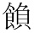” can be expressed as the IDS “⿰食負”, where IDC “⿰” indicates that”食” and “負” are combined left to right. Because one IDC can carry two to three building components and IDS can nest multiple IDCs, IDS are hard to recognize with regular expressions. Therefore, I used curly brackets instead of IDC, rendering “” into “｛食＋負｝”. In order to catch this sort of non-Unicode characters, all dots (“.”) in the regular expressions of table 3 need to be converted into r ‘(?:｛[^｝]+｝|.)’. Furthermore, the order of the application of the regular expressions can cause some ambiguities. In table 2, we temporarily do not pay closer attention to this problematic and show the markups and their regular expressions in the same order as in table 1.
If this regular expression is applied before r'^((?:.﹦)+)（[^）]+）' or r'^(.)（？）', it needs to be adjusted to r'^([^﹦])（([^？])）' in order to avoid ambiguities.
Depending on whether a sequence of following redundant characters is handled as one sequence or as separate character units, the regular expression may be in need to be adjusted to r'^〖([^〗]+)〗', akin to the supplement of damaged characters, which are always handled as a single sequence.
For a detailed description, see Hafner (2020).
“qǐjū乞鞫” means “begging for retrial”.
Occasionally, there does not exist a corresponding punctuation mark in modern Chinese. In these cases, the original punctuation mark is felt unnecessary in modern punctuation and regularization leads to an omission of the original punctuation mark. However, regularizations that accompany characters or mark omissions should be limited to situations where both unregularized and regularized transcriptions are provided. Otherwise, information about the original text is at risk to be lost.
The link to the page on which we publish digitalization experiments in Japanese is https://www.aa.tufs.ac.jp/~Ejina/DBexperimental.html . The script consists of four files, titled “TEI-Encoder(shakudoku02).py”, “classes.py”, “tools.py”, “tags.py”; “TEI-Encoder(shakudoku02).py” imports the other three files. The links to these files are: TEI-Encoder(shakudoku02).py https://www.aa.tufs.ac.jp/~Ejina/DBexp/07/TEI-Encoder(shakudoku02).py classes.py https://www.aa.tufs.ac.jp/~Ejina/DBexp/07/classes.py tools.py https://www.aa.tufs.ac.jp/~Ejina/DBexp/07/tools.py tags.py https://www.aa.tufs.ac.jp/~Ejina/DBexp/07/tags.py I must apologize that the documentation is only available in Japanese. However, this is merely an early experimental script that has been significantly modified by subsequent scripts, which include English documentation. See chapter 3.
In order to catch abbreviation expressions that stretch over two slips (or ‘lines’), the experimental script TEI-Encoder(shakudoku02).py applied the following regular expression after the one listed in the table: r'^((?:｛[^｝]+｝|[^（）＆﹦])(?:（？）)?＆?﹦＆?)$'. This expression catches unfinished abbreviations at the end of text lines, which can be stored in a temporary variable. When hovering over the next text line, the first match will be the second part of the same abbreviation expression, which then helps to restore the entire abbreviation and its expansion.
Available at https://www.aa.tufs.ac.jp/~Ejina/DBexp/07/Igokutojo(Zenjoho)02.txt.
The file is available at https://www.aa.tufs.ac.jp/~Ejina/DBexp/07/output(TEI-Encoder(shakudoku02))Text0.xml.
The XSL transformation file is available at https://www.aa.tufs.ac.jp/~Ejina/DBexp/07/koseiyou(zenjoho).xsl, the output result at https://www.aa.tufs.ac.jp/~Ejina/DBexp/07/Koseiyou(zenjoho).txt.
The XSL transformation file is available at https://www.aa.tufs.ac.jp/~Ejina/DBexp/07/Koseiyou(Hakubun).xsl, the output result at https://www.aa.tufs.ac.jp/~Ejina/DBexp/07/Koseiyou(Hakubun).txt.
The concept of phonetic loan characters is rather problematic. What I call regularization in this article is the change of original characters into characters whose meaning and reading can be recognized in accordance with nowadays commonly acknowledged character standards. This change is necessary because the usage of characters changes over time and space. We need to know the reference system in order to understand the character precisely. For us, the reference system may be the Kāngxī zìdiǎn康熙字典, Hànyǔ dà zìdiǎn漢語大字典, or other modern dictionaries, from which, of course, the character usage in excavated written materials deviates often. However, most of the characters discovered should be regarded as following a reference system that was commonly accepted at the time of writing. Thus, the majority of the characters we need to alter for our contemporary comprehension were conventional writing styles for the time. With regard to this fact, a strict definition of loan characters should only refer to loans that deviate from the general norm at the time of use.
The XSL transformation file is available at https://www.aa.tufs.ac.jp/~Ejina/TEI2026/ XSL-transformation(regularization_list).xsl, the output result at https://www.aa.tufs.ac.jp/~Ejina/TEI2026/ Regularization_list.txt.
Now, three comprehensive versions are available for the compilation. Hafner (2013) is the original version published in cooperation with the editorial committee of the Yuèlù-Academy; Wēn Jùnpíng et al. (2018) includes a revision done by Ōu Yáng歐揚; Hafner (2021) is an updated version by the author.
In my view, this should be the main reason that traditional editions of excavated written materials often provide “enriched” and “restrained” transcriptions as shown in figures 9 and 10 of the previous chapter.
See Hafner and Chén (2011) p. 413.
Nowadays, the glyph “黃“ denotes the character “huáng黃(=yellow)”. According to Táng Lán唐蘭, the initial shape of this character was an ideograph describing the meaning of “wāng尪 (=crooked spine)”, which would mean that the character “huáng黃(=yellow)” is a phonetical loan from “wāng尪”.
At this phase of the experiment, the glyph IDs are assigned in the order of appearance of the glyphs within the encoded text. As this could cause unnecessary confusion in case of comparing different texts, the method of glyph ID assignment will be discussed further in section 4 of chapter 4.
The script is available at https://www.aa.tufs.ac.jp/~Ejina/DBexp/09/compare.py. The text comparison module applied in this script has been developed by Dr. Wáng Xún王荀. The module is available at https://www.aa.tufs.ac.jp/~Ejina/DBexp/09/newdiff.py, English documentation is included in the file, a Chinese explanation is found in the supplement to Hafner (2025b).
It might be questionable whether the concept of “witness” is appropriate here. In diplomatic terms, the compilation as it was buried in a tomb is a “witness” of a certain ancient text. It is a more or less accurate copy of a certain text, which might have changed during its circulation among contemporaries. However, every modern transcription of the compilation arranges the excavated slips in different orders, again creating different witnesses of the same text, which was once copied, buried and eventually survived up to today. In this sense, this paper regards different transcriptions as different witnesses.
Initially, the author intended to use the @wit attribute. However, the @wit attribute is not permitted in <p> elements. “compare.py” uses the @source attribute instead, which is allowed in <p> elements as well as <lem> and <rdg> elements. It might well be that the author’s misunderstanding about the semantic meaning of the two attributes caused this permission conflict.
To avoid unnecessary confusion, we treat the slip ID numbers as unquestioned premises in our collation experiment. In truth, the identification and numbering of excavated writing material can be quite intricate and challenging. As for the case of the Yuelu-Academy bamboo and wood text collection, I was forced to write an entire book about this topic after my involvement in the first edition of the compilation, which was a part of this collection. See Hafner (2016).
In the initial text edition, the recognized slips were numbered from 1 to 253; missing slips were numbered from 1 to 15, adding the suffix “quē缺 (=missing)”. When the revised edition included newly recognized slips, their IDs were decided depending on their relative position within the initial slip arrangement. For instance, a slip inserted behind slip 244 was assigned the number 244(2). As xml:id attributes don’t permit integer only IDs, all IDs were suffixed with the character “J”. The digit was also adjusted by adding “0”s between the character “J” and the original ID. Furthermore, brackets were replaced by the characters “S” (=“(”) and “E” (“)”). As a result, the conversion of slip numbers into @xml:id attributes produced three slightly different formats: 1) “J\d\d\d”, ranging from “J001” to “J253”; 2) “J缺\d\d”, ranging from “J缺01” to “J缺15”; 3) “J\d\d\dS\dE”, with 6 unordered occurrences.
As comparison modules return output not term by term but in units of sub-sequences, 3c and 3d often overlap. For instance, taking the revised edition from 2021 as main witness and the initial edition from 2013 as second witness, one of the comparison outputs states that the sub-sequence of slip 244(2) and 244(3) in the main witness is replaced by the sub-sequence of slip 245, 246, 247, and 248. While slip 245 and 246 appear in both witnesses, slip 244(2) and 244(3) are unique to the main witness, in contrast to slip 247 and 248 which exclusively appear in the second witness. That means that with regard to the slips 244(2) and 244(3), we observe the situation 3c), and with regard to the slips 247 and 248, we are confronted with situation 3d).
This method of processing the results of type IV) is prone to causing some trouble in the future and, therefore, needs further refinement. If slip IDs that are not found in the main witness appear at two different positions in two other witnesses, the current processing method leads to repeated recording of the same slip. This is a redundancy that will easily result in further difficulties if, for instance, the transcriptions of these witnesses differ. One solution would be to create a separate <div> element that stores in <p> elements the slip text of slips not entailed in the main witness. Taking the witness in which the slip first occurs as a main witness for this particular slip, the handling of differences between the following witnesses could be handled in analogy to the slip texts stored in the main text body. This processing method can be viewed as a form of recursive creation of main witnesses and their comparison with other witnesses.
Be aware that the ID “094(2)” is replaced by “094S2E” in the XML file “output(collated).xml” due to restrictions on XML identifiers.
This does not mean that the text on slip 095 needs to be identical in both witnesses. The differences between the slip text are recorded in a second collation process by creating an apparatus for each differing character separately.
With regard to the text of the slips 缺08 and 缺10, it needs to be mentioned that the difference in their respective transcription methods stems from the difference in their recognition. Though slip缺08 was reconstructed as a missing slip, the transcription of its slip text was directly based on imprints on the verso of slip 104. The slip text was handled as existing within the witness itself and not as a supplement by the transcriber. By contrast, the text of slip缺10 is a pure supplement by the transcriber. In a traditional analog transcription, two different types of transcription could be provided for such a case. One merely records the loss of the slip by the markup symbol “〼” (see legend in 2.2). This markup is converted into a <g> element with the @ref attribute “gap03”. It is one of three elements predefined for the description of gaps. The other type of transcription puts the entire reconstruction of the slip text into black lenticular brackets (“【】”). For instance, the text of slip 缺10 was reconstructed as “【某曰：……】”. Since this is a supplement for a loss by damage, this text will be stored in a <div> element within the back matter extraordinarily dedicated to such supplements and linked to the simplified slip text “〼”.
“#Range” refers to a sequence of one or more elements, while “#left” refers to the position before a certain element. See TEI Consortium, eds. “17.2.4 TEI XPointer Schemes”, Guidelines for Electronic Text Encoding and Interchange P5 Version 4.11.0. Last updated on 18th February 2026, https://tei-c.org/release/doc/tei-p5-doc/en/html/SA.html#SATS (accessed on July 6th,2026).
The Unicode Consortium, whose understanding and representation of Chinese characters will be discussed below, uses the term “ideograph”, but explicitly delineates the distinction between the representation of a morpheme (=logograph) and the representation of ideas or concepts: “Notionally, a logograph (or logogram) is a unit of writing which represents a word or morpheme, whereas an ideograph (or ideogram) is a unit of writing which represents an idea or concept. However, the lines between these terms are often unclear, and usage varies widely. The Unicode Standard makes no principled distinction between these terms, but rather follows the customary usage associated with a given script or writing system. For the Han script, the term CJK ideograph (or Han ideograph) is used.” (Unicode Consortium (2025, p.329 /2014, p.258). In addition, specifically concerning Chinese characters: “The term ‘Han ideographic characters’ is used within the Unicode Standard as a common term traditionally used in Western texts, although ‘sinogram’ is preferred by professional linguists. Taken literally, the word ‘ideograph’ applies only to some of the ancient original character forms, which indeed arose as ideographic depictions. The vast majority of Han characters were developed later via composition, borrowing, and other non-ideographic principles, but the term ‘Han ideographs’ remains in English usage as a conventional cover term for the script as a whole.” (Unicode Consortium (2025, p.930/2006, p.409) The basic stance on Chinese characters of the Unicode consortium apparently was basically consolidated by version 3.0 in 1998, with minor modifications in later versions. Here and below, quotations are therefore made from the latest version together with a reference to the earliest mention found by the author, separated by a slash.
Morioka (2023) p.1: 「漢字は1字が古典中国語の1形態素に対応する表語文字と考えることができ、伝統的に形音義にかかわる諸要素の組合せや対応関係によって分析・整理されてきた。」 With regard to the trinity of shape, sound, and meaning, the reader may prefer to refer to the classical work of Wáng Lì on this topic, see Wang (1953).
The Japanese readings appear to have departed furthest from the Guǎngyùn standard. Still, there are traces of Guǎngyùn sounds in Japanese usage of Chinese characters that have been lost in modern Chinese. For instance, the syllable “tsuつ” in the reading of “しつ室” derives from an ending consonant in the Guǎngyùn reading “式質”, which has been lost in the modern Chinese reading “shì”. The Korean readings appear to adhere most closely to the Guǎngyùn standard, though such a statement might collide with either Korean or Chinese modern national narratives.
The divergence from this standard apparently is more significant in modern Chinese dictionaries as they do not consciously discern between meanings deriving from this traditional common ground and modern creations.
The Unicode Consortium（2025, p47 /1999, p.5）.
The Unicode Consortium（2025, p935-936 /1999, p. 260-261）.
The Unicode Consortium（2025, p940 /1999, p.263）.
The Unicode Consortium（2025, p940 /1999, p.263）.
The Unicode Consortium accurately identifies the practicality issue regarding “Distinguishing Han Character Usage Between Languages”: “There is some concern that unifying the Han characters may lead to confusion because they are sometimes used differently by the various East Asian languages. Computationally, Han character unification presents no more difficulty than employing a single Latin character set that is used to write languages as different as English and French. Programmers do not expect the characters ‘c’, ‘h’, ‘a’, and ‘t’ alone to tell us whether chat is a French word for cat or an English word meaning ‘informal talk.’ Likewise, we depend on context to identify the American hood (of a car) with the British bonnet. Few computer users are confused by the fact that ASCII can also be used to represent such words as the Welsh word ynghyd, which are strange looking to English eyes. Although it would be convenient to identify words by language for programs such as spell-checkers, it is neither practical nor productive to encode a separate Latin character set for every language that uses it. …… The Unicode Standard leaves the issues of language tagging and word recognition up to a higher level of software and does not attempt to encode the language of the Han characters.” (The Unicode Consortium（2025, p. 936-937/1999, p.261) This is correct, but regarding a morphographic script that is supposed to represent morphemes, this does not alter the fact that the Unicode Standard encodes glyphs rather than characters. Within the traditional trinity of shape, sound, meaning, Unicode code points merely correlate to shape. That is sufficient for practical purposes such as the Unicode Consortium pursues, but a linguistically reliable description of Chinese writing as a morphologic script needs further exploration.
Qiū (1988, p. 15/22). Page numbers before the slash refer to the revised Chinese version from 2013, while the numbers after the slash correspond to the English translation by Mattos and Norman.
Ibid., p. 12/18.
Ibid., p.3/5.
That Qiū nevertheless sticks to the denomination “semanto-phonetic script” is based on the facts that “signs of the later stages are almost completely derived from semantic and phonetic symbols,” and that “a majority of characters are still formed from semantic and phonetic symbols.” (Ibid., p.15/22)
Ibid., p.9/13. Mattos and Norman render the original term “wénzì文字” as “writing”, a choice I believe dilutes the emphasis of this passage.
Ibid., p.10/14. Here, Mattos and Norman translate “wénzì文字” as “writing system”.
Ibid., p. 9/13. Be aware that the second “symbol” in this passage refers to “graphic symbol”. This sentence precedes the definition of “graphic symbols”. Hence, this passage still uses the general term “symbol (=符號)” in an ambiguous manner.
Ibid., p. 10/14.
In this regard, the translation of “hétǐ zì合體字” and “dútǐ zì獨體字” as “composite character” and “non-composite character” is at least misleading. “dútǐ獨體” actually means “stand-alone body/item”, and “hétǐ合體” means “conjunctive body/item”. Hence, “one-component character” and “multi-component character” may come closer to Qiū’s original concept.
According to Qiū, the standard script shape of “日” does not resemble the sun anymore. Hence, it has stopped being a pictographic symbol and turned into a “sign”. See Ibid., p. 12/14.
Ibid., p. 11/16.
Ibid., p. 16-17/24.
Ibid., p. 18/26. The second sentence of this passage was omitted in Mattos’ and Norman’s English translation and was reinstated by the author of this article. The original text reads “前者着眼於字符所能表示的語言結構的層次，後者着眼於字符的表意、表音等作用.” Strictly speaking, Qiū failed to comply with his own distinction between the two levels of symbols in this sentence. Following the distinction, the first “graphic symbol (=字符)” should be changed to “characters (=wénzì文字)” or “Chinese characters (=hànzì漢字)” as language is represented by characters and not by graphic symbols. Morphemic theory puts the focus of interest on the relationship between characters and language, while Qiū’s theory focuses on how graphic symbols comprise characters as symbols representing language.
In comparison to the morphemic perspective, one could argue that Qiū’s understanding of linguistics is still an old-fashioned rule-based language model. While the morphemic perspective focuses on phenomenologically describing how certain characters represent certain language features, Qiū relentlessly asks for the rules that make these representations possible. This very much resembles the ruled-based language models of traditional European grammarians, which apparently have been proven inaccurate by deep learning language processing models and, recently, by large language models.
Ibid., pp. 261-263/397-398. Takashima , Ken-ichi (髙嶋謙一) already notd this highlight on page xxiv in his foreword for the English translation of Qiū (1988).
Ōnishi and Miyamoto (2009).
Shào (2015), p.73-74.
Ibid., p. 73-74.
Ibid., p. 76. “經過歸並之後，每個字位下領屬若干形體，構成一個字族；同一字族中，包含一個字位各種不同的形體，如甲骨文，金文，小篆，隷書，各種異體和異寫形式等；由於内部建立了有效的連接，無論選擇哪個形體作爲檢索項，都可以獲得該字位的全部形體的查詢結果。”
One might speculate an etymological connection between the two terms, as the punishments to which the word “fǎ灋” refers are mainly mutilative punishments. Mutilation might be associated with disability, disuse, waste, and so on. However, such connections cannot be proven by paleographic material of the said period of time.
Duàn Yùcái段玉裁 (1735-1815) considers it a semantograph or syssemantograph (huìyì zì會意字), Xú Kǎi徐鍇 (920-974) a phonogram (xíngshēng zì形聲字).
In this case, “qǔ取” is generally regarded as a phonetic symbol, turning the character “jù冣” into a phonogram.
Furthermore, the component “mì冖” in both the character “jù聚” and the component “mào冃” within the character “zuì最” are often written in the form of “mián宀”, but this change will be ignored in the subsequent discussion.
Ōkawa (2015).

